

**The Department of Medical Engineering**

Project Name:   
Diagnosis of Parkinson's Disease Using Analysis of Speech Signal

Project Book

|  |  |
| --- | --- |
| Students name: | Shir Cofman 312500697  Meital Hallo 205701618 |
| Instructor name: | Yirmi Hauptman |
| Submission date: | 02/06/2019 |

**Acknowledgment**

We would like to express our deepest appreciation to our supervisor, Yirmi Hauptman, for giving us the privilege to participate in this important project, for the endless support, time investment and patience throughout the process. We are truly grateful for his availability and willingness to assist in any time of need. His guidance was enlightening and enriching, and his consult truly broadened our horizons.

**Table of Content**

1. Lists 5

1.1 List of Figures 5

1.2 List of Tables 5

1.3 List of Equations 6

2. תקציר מנהלים 7

3. Executive Summery 8

4. Terms Dictionary 9

5. Introduction 9

6. Goals and Objectives 10

7. Literature Review 11

7.1 Parkinson's Overview 11

7.1.1 Pathophysiology 11

7.1.2 Signs & Symptoms 11

7.1.3 Diagnosis 12

7.1.4 Treatment 13

7.2 Parkinson's Effect on Speech 13

7.2.1 Anatomy and Physiology of Speech Production Process 13

7.2.2 Speech Characteristics in Parkinson's Disease 15

7.3 Previous Researches 17

7.4 Prominent Acoustic Characteristics 19

7.4.1 Jitter 19

7.4.2 Shimmer 19

7.4.3 Harmonic to Noise Ratio 20

7.4.4 Pitch 20

8. Methods 22

8.1 Main Script ("MainRun") 23

8.2 Analyze Records ("Create Feature Matrix") 23

8.2.1 Extract Database ("Process Excel") 24

8.2.2 Voice Activity Detection ("VAD") 24

8.2.3 Feature Extraction ("CalcFeatures") 26

8.2.4 Calculate Statistics for a Feature-Vector Per utterance ("CalcStati") 38

8.3 Classification Algorithm ("Machine Learning") 38

9. Results 40

10. Discussion 47

11. Summery and Conclusion 48

12. Suggestions for Future Work 49

13. Project Planning 50

13.1 Final Work Plan 50

13.2 Changes Assemblage 51

14. References 52

14.1 Article 52

14.2 Figure 53

15 Appendix 54

15.1 Poster 54

15.2 Relevant Article 54

15.3 Advisor's Approval 54

# 1. **Lists**

## **1.1 List of Figures**

Figure 1 - Symptoms of Parkinson Disease 12

Figure 2 – Simple View of Speech Production 13

Figure 3 – VAD algorithm results for sustain vowel \Ha\ 25

Figure 4 – VAD algorithm results for counting one-to-ten in Hebrew 25

Figure 5 – VAD algorithm results for \Shemesh\ 25

Figure 6 – Plot of \Ha\ Audio Signal and First Four Frames 26

Figure 7 - Power Spectrum and its close-up on harmonic and noises part of HC (a) and PD (b) speakers. 27

Figure 8 – Original frame (a) and the frame after using Clipping threshold algorithm (b). 28

Figure 9 – Frame's Autocorrelation. The marked line represents the highest value of the autocorrelation, the pitch. 28

Figure 10 – Pitch per frame by Pitch algorithm (Left) and by Praat software (Right) 29

Figure 11 – The slope of maximum and minimum peak in HC (Left) and PD (Right) speakers. 29

Figure 12 – Plot of Chosen Window 30

Figure 13 – Plot of Running Window at different index 30

Figure 14 - Results of "FindPeaks" algorithm of PD subject 31

Figure 15 - Jitter and shimmer differences between healthy (a) and diseased (b) speakers 31

Figure 16 - Plot of Distorted Frames 32

Figure 17 – Normal frame (Left) and Special frame (Right). 33

Figure 18 – Deviation of Period above 30% 34

Figure 19 – Frame with Low Number of Peaks 34

Figure 20 – Original Signal (Left) and its Smooth Presentation (Right) 35

Figure 21 – Pitch gradient (a) and RMS gradient (b) of HC and PD speakers. 36

Figure 22 – Autocorrelation Amplitude Per Frame of PD and HC Speakers. 37

Figure 23 – Zoom On the 6 First Peaks of Autocorrelation (a) and its Slope (b) 37

Figure 24 – Entropy Per Frame of PD (Left) and HC (Right) Speaker 38

Figure 25 – Histograms of HNR, RMS Changes, Entropy and 'S' Features For MPT 42

Figure 26 – Histograms of Speech Rate and Lengths Statistics for Continuous Speech 42

Figure 27 – RMS Changes (STD), Special Frames in Frequency Domain and HNR (max-mean) Features, with Max Accuracy of 80.4% 44

Figure 28 – Silence Lengths Statistics of Entropy and STD Features, for "Thousand Islands" reading passage, with Max Accuracy of 87.2% 44

## **1.2 List of Tables**

Table 1 – List of Acoustic Features 17

Table 2 - Accuracy of MPT Features 40

Table 3 - Accuracy of MPT Features 40

Table 4 - Accuracy of MPT Features 41

Table 5 - Accuracy of Continuous Speech Features 41

Table 6 - Accuracy, Senstivity and Specifity for Different Combination of Features 44

Table 7 - Best Results of Each Feature 45

Table 8 - Accuracy, Sensitivity and Specificity Results of Classical and SF Features 46

Table 9 – Change Assemblage Summarize 51

## **1.3 List of Equations**

*Equation 1* 19

*Equation 2* 19

*Equation 3* 19

*Equation 4* 20

*Equation 5* 20

*Equation 6* 20

*Equation 7* 20

*Equation 8* 20

*Equation 9* 21

# 2. תקציר מנהלים

מחלת הפרקינסון היא מחלה כרונית ומתקדמת הגורמת לניוון בתפקודים המוטוריים וכוללת קושי מוגבר בהפקת דיבור ברור. נכון להיום, לא קיים כלי אבחון ספציפי לפרקינסון, והמחלה מזוהה בעיקר על ידי נוכחות של סימפטומים מוטוריים. בשל הדמיון בין הסימפטומים של מחלה זו לבין הפרעות נוירולוגיות אחרות, שיעור האבחון השגוי עומד בקירוב על 10-25% מהמקרים. לזיהוי מוקדם של פרקינסון קיימת חשיבות רבה בהאטת התקדמותו ובהגדלת האפקטיביות של טיפולים ותרופות שונות ולכן, דרוש כלי נוסף ויעיל לאבחון מוקדם ומדויק יותר של פרקינסון.

מטרת הפרויקט המוצג היא להשתמש באלגוריתמים של למידת מכונה לזיהוי של דוברים חולי פרקינסון על בסיס שינויים במאפיינים אקוסטיים של דיבור. סט הנתונים מבוסס על 48 דוברים, בריאים וחולים, כאשר לכל דובר יש כ-10 הקלטות שונות: הקלטות של /אה/, /פה-טה-קה/ ודיבור רציף.

מספר מחקרים קודמים הראו יכולת לזהות את מחלת הפרקינסון על ידי ניתוח שינויים אקוסטיים בדיבור ושימוש בשיטות שונות של מכונה לומדת. מסד הנתונים של מחקרים אלה הכיל 195 הקלטות וכללו הוצאת מאפיינים במרחב הזמן ובמרחב התדר, כגון: תדר בסיסי, יחס בין הרמוניות לרעש, שימר, ג'יטר ועוד. אלגוריתמי מכונה הלומדת במאמרים שנסקרו אשר הראו את הביצועים הטובים ביותר בזיהוי פרקינסון, בן היתר, הם אלגוריתם שכן קרוב (KNN) ומכונת וקטורים תומכים (SVM) עם שיעור של כ-90% דיוק.

במסגרת התהליך, נבחרים מאפיינים אקוסטיים קורלטיביים עם מחלת פרקינסון. עיבוד מקדים של ההקלטות נעשה באמצעות תוכנת MATLAB, הכולל חלוקת האות למסגרות ויישום של אלגוריתם לזיהוי חלקים קוליים. לאחר מכן, המאפיינים האקוסטיים שנבחרו ממומשים באופן עצמאי, חלקם בהסתמך על מאמרים קודמים, כמו ג'יטר, שימר, יחס בין הרמוניות לרעש ותדר בסיסי של הקול. שלב זה כולל ניתוח סטטיסטי של המאפיינים, באם האלגוריתם מחזיר ערך לכל מסגרת. יכולת ההפרדה בין נבדקים בריאים לבין חולים נבחנת באמצעות מסווגים של מכונה לומדת: אלגוריתם שכן קרוב (KNN) ומכונת וקטורים תומכים (SVM) בעוד שרק המאפיינים הנותנים את תוצאות זיהוי גבוהות נבחרים.

החידוש במחקר המוצג הוא הפקת תכונות נוספות, מקוריות מאות הדיבור שאינן מופיעות בספרות או במחקרים קודמים. מטרת פרמטרים אלה היא להעריך את אופיו המחזורי של האות ולכמת את רמת אי הסדירות באות, ובכך לזהות קול של חולה פרקינסון. בנוסף, למיטב ידיעתנו, מחקר זה מסתמך על מסד נתונים מאוזן, מקצועי וגדול (מעל 350 הקלטות).

# 3. Executive Summery

Parkinson's disease is a chronic, progressive disorder that causes degeneration in motor functions and includes increased difficulty in producing clear speech. To date, no specific diagnostic tool exists, and the disease is primarily identified by the presence of motor symptoms. Due to the similarity of symptoms between this disease to other neurologic disorders, the rate of misdiagnosis stands on approximately 10–25%. Early identification of Parkinson has great importance in slowing down its progress and in increasing the effectiveness of different treatments and medications. Therefore, additional and more effective tool is needed to diagnose Parkinson earlier and more accurately.

The objective of this project is to use machine learning algorithms for identification of Parkinson diseased speaker based on changes in speech acoustic characteristics. The data set is based on 48 speakers, healthy and diseased subjects, each has approximately 10 different records: records of /AH/, /Pa-Ta-Ka/ and continuous speech.

Several previous studies have shown the ability to identify Parkinson's disease by analyzing the acoustic changes of speech and by using machine learning methods. These studies databases contained overall 195 records and included extraction of both spectral and time domain features, such as: F0, HNR, shimmer, jitter etc.The machine learning algorithms that showed the best performance in recognizing Parkinson's disease, among others, were SVM and KNN, with approximately 90% rate of correct identification.

As part of the process, acoustic characteristics that correlate with Parkinson disease are selected. Pre-processing of the records is done using MATLAB software, including division of the audio signal into frames and application of voice activity detection algorithm. Then, the selected acoustic characteristics are independently implemented, some based on previous articles, as jitter, shimmer, HNR and pitch. This phase includes statistical analysis of the features, if the feature returns value per frame. Their separation capability between healthy and Parkinson's disease subjects is examined using machine learning classifiers of KNN and SVM while only those that provide high identification results are selected.

The novelty of the presented study is extraction of additional and original features that do not appear in the literature or in previous studies. These parameters aim to evaluate the periodic nature of the signal and to quantify the level of the irregular frames, and with it, to identify "Parkinson voice". Moreover, this study relies on a balanced, professional and large database (more than 350 records).

# 4. Terms Dictionary

1. PD - Parkinson's disease
2. HC - Healthy Control
3. SF – Special Frames
4. CS - Continuous Speech
5. F0 - Fundamental Frequency
6. NHR - Ratio of Noise-to-Harmonic
7. HNR - Ratio of Harmonic -to- Noise
8. SNR - Signal to Noise Ratio
9. VAD - Voice Activity Detection
10. LPC - Linear Predictive Coding
11. SVM - Support Vector Machine
12. KNN - K-Nearest Neighbors
13. STD – Standard Deviation
14. STFT – Short Time Fourier Transform
15. DTW - Dynamic Time Warping
16. PCA - Principal Component Analysis

# 5. Introduction

Parkinson's disease (PD) is chronic, progressive and one of the most common neurodegenerative disorder effecting approximately 10 million people globally. The disease is caused by degeneration of dopamine-generating cells in the substantia-nigra, a region of the midbrain, creating loss of dopamine, a neurotransmitter that is critical for movement.

The disease is characterized by both motor and nonmotor features; rest tremor, rigidity, balance impairment, slowness of movement and mood, cognition and behavior alterations [‎1]. PD is also reflected in increasing difficulties in producing clear and normal speech. Previous studies reported that approximately 70–90% of PD patients show some form of vocal impairment, and that this deficiency may be one of the earliest indicators and symptom of the disease [‎2].

Early detection of Parkinson's disease has great importance in increasing the effectiveness of different possible treatments and medications and so, in slowing down the disease progress. Diagnosing PD accurately, particularly in [early stages](https://parkinsonsdisease.net/diagnosis/early-symptoms-signs/), may be difficult since its symptoms resemble other medical conditions, and so, misdiagnosis is reported to occur approximately in 10–25% of cases [‎2]. Therefore, a more accurate tool is needed to aid diagnosing this disease.

The objective of this research is to train a Machine learning classification algorithm that best characterize "Parkinson voice". Through this process, different acoustic characteristics are researched and implemented using MATLAB, and their separation capability and identification percentage are examined. Our goal is to find vocal features of the disease that show high accuracy and performance, when it cannot be anticipated ahead.

This kind of project can provide additional tool for early diagnose of PD and help in monitoring the progression of the disease.

# **6. Goals and Objectives**

The primary goal of the presented project is to develop an automatic algorithm, machine learning based, to aid in the detection and evaluation of Parkinson's disease. The classification algorithm is based on extraction of acoustic features from speech that correlate with the disease. The project seeks to reveal features that best characterize the disease and their changes in speech.

This kind of speech analysis can be used as tele-detection tool in order to calculate the probability of pathology. For example, through a smartphone application. when the voice changes manifest Parkinson characteristics, a warning notification will recommend for further medical diagnostics. Moreover, it can be used as tele-monitoring of patient's disease progress and might be able to provide additional feedback in speech therapy for the speech therapists or for the patients themselves.

# **7. Literature Review**

## **7.1 Parkinson's Overview**

### **7.1.1 Pathophysiology**

Parkinson's disease (PD) is a chronic and progressive disorder that affect the nervous system that usually affects people over the age of 60. The nervous system is made up of units called nerve cells or neurons. Neurons serve as a "communication network" between the brain and the body that communicate with each other using chemical messengers called neurotransmitters. Normally, neurons in the substantia nigra (a region in the midbrain responsible for motor control) produce a neurotransmitter known as dopamine, which is critical for movement and helps transmit messages between cells in the brain and brain to muscles to make sure muscles produce smooth, purposeful movement. Loss of dopamine due to degeneration of neurons in substantia nigra results in abnormal nerve firing patterns that impair movement. By the time Parkinson’s is diagnosed, most people have lost an estimated 60 to 80 percent of their dopamine-producing cells in the substantia nigra [‎1,‎3].

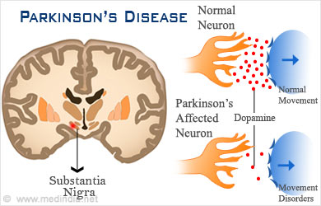

‎1 - Schema of Pathology

An additional factor considered to be a marker for neuronal degeneration is the presence of Lewy bodies - an abnormal aggregate of protein that develop inside nerve cells, along with the buildup of excessive and abnormal quantity of alpha-synuclein, that is the primary structural component of Lewy bodies. The presence of them, along with abnormalities in the substantia nigra, become a recognized pathologic marker of the disease [‎1,‎3].

### **7.1.2 Signs & Symptoms**

The preclinical phase of the disease patients exhibits non-motor symptoms such as sleep-behavior disorder (acting out vivid dreams), constipation, depression, anxiety and alteration of speech characteristics and olfactory disturbance. People may also experience disturbances the autonomic nervous system that manifest as problems with digestion, respiration, salivation as well as excessive sweating or bladder dysfunction. These symptoms typically precede the motor symptoms by several years [‎3].

The clinical phase characterized with the appearance of motor symptoms. Patients may have a variety of symptoms including resting tremor (involuntary shaking), bradykinesia (slowness of movement and reflexes), stiffness in their limbs or the trunk of their body and balance problems. The progression of these symptoms is typically gradual, often involving only one side of the body at first and includes reduction of arm swing on one side when walking, soft speech or intermittent tremor. As these symptoms progress, walking, talking, swallowing, and completing other simple tasks can become challenging [‎3].

Figure 1 - Symptoms of Parkinson Disease

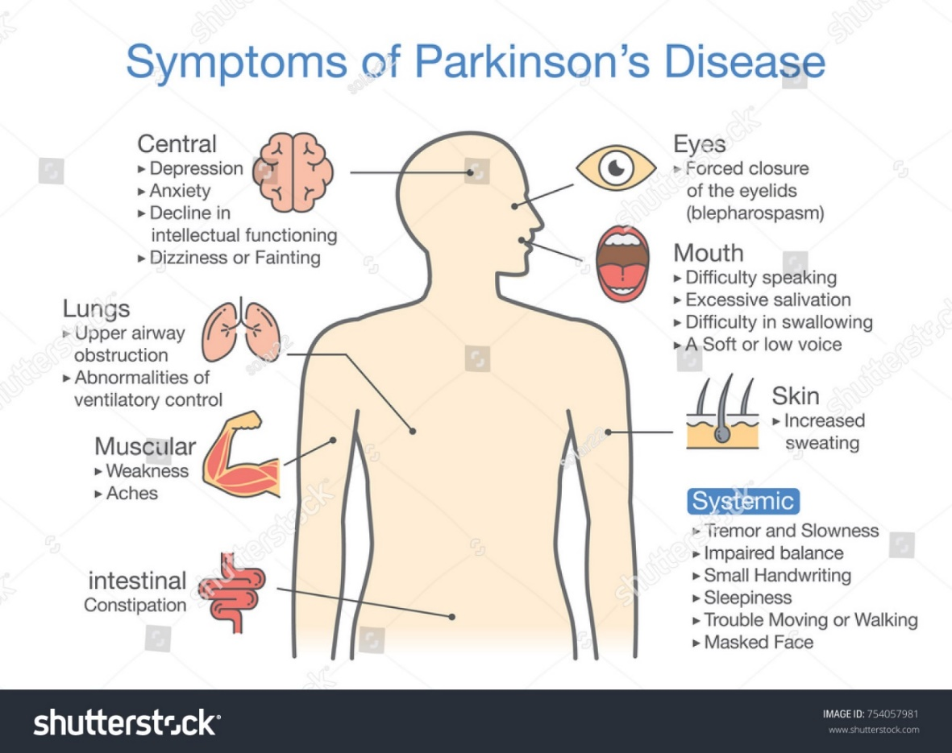

### **7.1.3 Diagnosis**

Currently, no specific blood or laboratory tests exists that have been proven to help in diagnosing PD. Therefore, the diagnosis is based on medical history and a neurological examination and is primarily identified by the presence of motor symptoms, including slowness of movements (bradykinesia) and at least one of the following symptoms: resting tremor, muscle rigidity, and postural instability. Diagnosing Parkinson’s disease accurately may be difficult since its symptoms resemble other medical conditions, and so misdiagnosis occurs occasionally approximately in rate of 10–25% [‎3].

Confirmation of a PD diagnosis also involves exclusion of other diseases that produce similar symptoms to those of Parkinson’s disease, such as stroke or brain tumors. In some cases, diagnosis can be completed by imaging techniques such as magnetic resonance image (MRI), positron emission tomography (PET scan), and single photon emission computed tomography (SPECT) [‎4].

### **7.1.4 Treatment**

Parkinson's disease is still incurable whereas the main goal of treatment is to manage the symptoms and provide relief for the patients. There are several available medicines for management of its symptoms when Levodopa is the primary treatment for symptomatic patients, that increases the levels of dopamine in the brain. Levodopa is particularly effective at controlling bradykinesia and rigidity, but speech, postural reflex, and gait disturbance are less likely to respond. However, motor complications and drug-induced dyskinesia limit its long-term use. After levodopa-related motor complications are developed, it is beneficial to initiate adjuvant therapy with dopamine agonists, catechol O-methyltransferase inhibitors, or monoamine oxidase-B inhibitors. Dopamine agonists directly stimulate dopamine receptors and have been shown to delay the onset of motor complications. However, dopamine agonists are inferior to levodopa in controlling motor symptoms [‎5].

Surgical treatment is becoming more common for Parkinson’s disease with the advances in brain imaging and neurosurgical techniques. An evidence-based review concluded that deep brain stimulation of the subthalamic nucleus improves motor function and reduces motor fluctuations and dyskinesia. Also, physical therapy, including stretching, strengthening, and balance training, may improve gait speed, balance and participation in activities of daily living, while speech therapy effectively treats speech disorders [‎5].

## **7.2 Parkinson's Effect on Speech**

### **7.2.1 Anatomy and Physiology of Speech Production Process**

Speech sound is a wave of air that originates from complex actions of the human body, supported by three functional units: generation of air pressure, regulation of vibration, and control of resonators. Speech is produced by an air stream flowing from the lungs, through the trachea and the oral and nasal cavities and involves four processes: Initiation, phonation, oro-nasal process, and articulation.

The organs responsible of producing speech are the lungs, larynx (includes vocal folds) and vocal tracts (teeth, tongue, lips, lower jaw etc). The larynx modulates the airflow from the lungs and provides a periodic puff-like or a noisy airflow source to the vocal tract. The vocal tract consists of oral, nasal, and pharynx cavities, giving the modulated airflow its “color” by spectrally shaping the source. This is illustrated in Figure 3 [‎6].

Figure 2 – Simple View of Speech Production

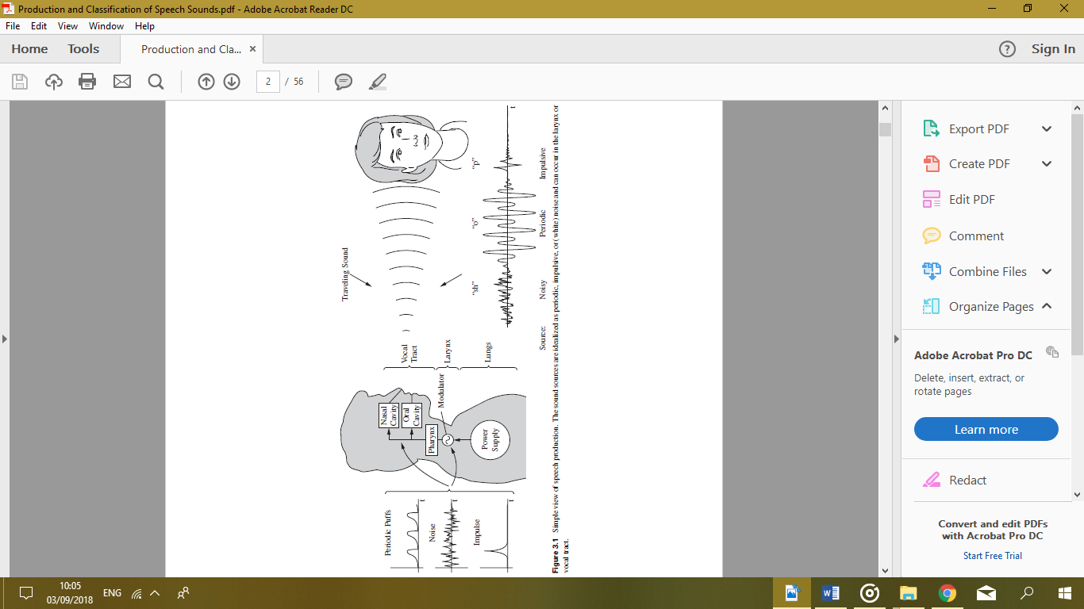

During speech, spurts of air are taken in and released steadily by controlling the muscles around the rib cage. We override our rhythmic breathing by making the duration of exhaling roughly equal to the length of a sentence or phrase. During this timed exhalation, the lung air pressure is maintained at approximately a constant level, slightly above atmospheric pressure, by steady slow contraction of the rib cage [‎6].

Figure ‎4 – Cross sectional view of the anatomy of speech production.

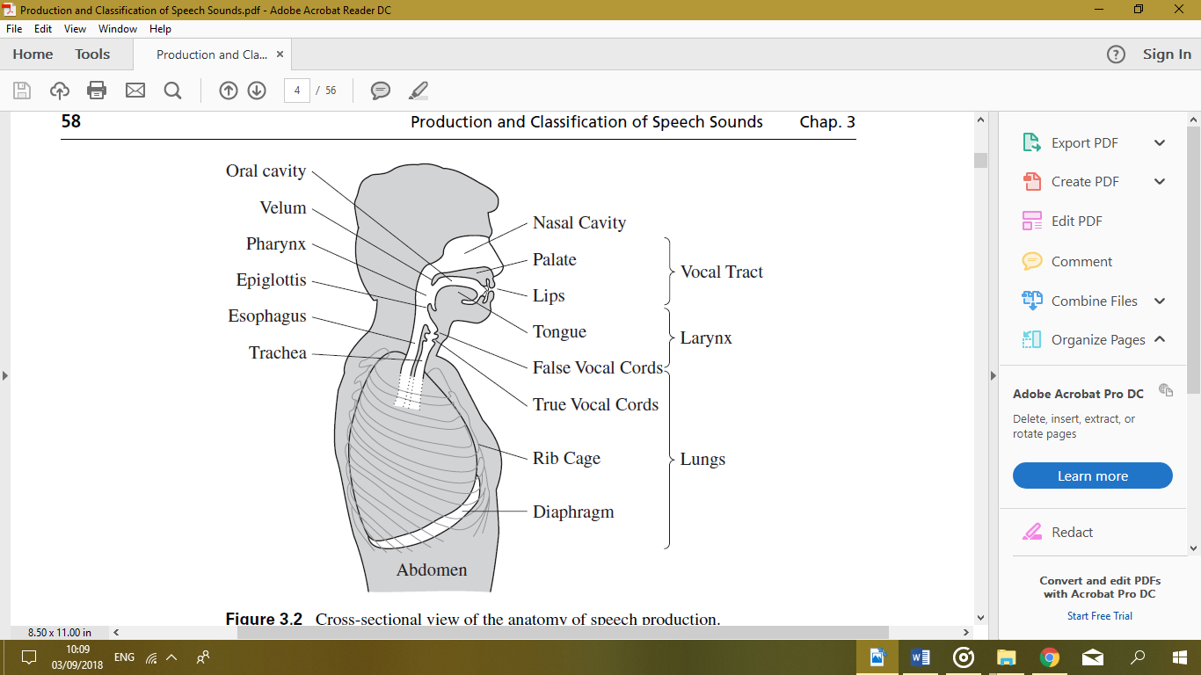

The phonation process occurs at the larynx. The larynx is involved in breathing, producing sound, in protecting the trachea against food aspiration and in manipulating pitch and volume, which is essential for phonation. The larynx has two horizontal folds of tissue in the passage of air called vocal folds. The gap between these folds is called the glottis [‎6].

There are three primary states of the vocal folds: breathing, voiced, and unvoiced. In “voiced sounds” the vocal folds get close to each other resulting the glottis to have a narrow opening which make the vocal folds vibrate when air is passing through. Their vibration rate determines the fundamental frequency of speech. The glottis can be wide open, as in normal breathing, and thus, producing “voiceless sounds” that are created without vocal folds vibration. The vocal cords are controlled by a set of muscles that can change the size and shape of the vocal tract, make the vocal tract longer, shorter, give it a wider opening, or firm up its walls. Every time the size and shape changes anywhere along the container of air, the change has a drastic effect on what parts of the original sound are amplified or filtered out [‎6].

After it has gone through the larynx and the pharynx, the air can go into the nasal or the oral cavity. The articulation process takes place in the mouth and it is the process through which we can differentiate most speech sounds. These cavities act as resonance chambers and as a bandpass filter to transform the laryngeal buzz or turbulence sounds into the sounds with special linguistic functions. The vocal tract includes upper and lower lips, upper and lower teeth, tongue (tip, blade, front, back) and roof of the mouth. So, speech sounds are distinguished from one another in terms of the place where and the manner how they are articulated [‎6].

### **7.2.2 Speech Characteristics in Parkinson's Disease**

Speech disorder in Parkinson, also known as hypokinetic dysarthria, results from muscle disorders of the speech mechanism due to damage of the central nervous system. It designates problems in oral communication due to paralysis, weakness, or disobedience of speech muscles. These disabilities tend to increase as the disease progresses and can lead to serious problems in communication. Previous studies report that approximately 70%–90% of patients with PD show some form of vocal impairment, 45–50% show alterations in articulation and this deficiency can be also an early indicator of the disease [‎2].

The prominent speech characteristics associated with hypokinetic dysarthria as seen in Parkinson’s disease are characterized by reduced vocal loudness and vocal decay, meaning that over time there is a fading in loudness. It is also characteristics by hypophonia, hoarseness, harshness, breathiness in speech, reduced pitch, mumbled and slurred speech resulted by imprecise production of consonants and distorted vowels. There are inappropriate pauses and hesitation when beginning to speak, as well as some dysfluencies and voice tremor, especially when the patient is asked to sustain phonation over time [‎2].

The ability to speak can be subdivided into several dimensions: respiration, phonation, articulation, and prosody. Each create different impact on speech characteristics:

* Respiration dysfunction, such as shortness of breath, contribute to some of the prominent features of the disorder, that relate to rigidity of the chest wall, hypokinesia and difficulty in initiating speech. This causes reduced loudness during vowel prolongation, reduce maximum vowel duration, short phrases and rushes of speech and inappropriate pauses. Can also cause an increase respiratory rate, irregular breathing patterns and difficulty altering automatic breathing patterns for speech [‎7].
* Phonation is the vibration of the vocal folds to create voiced sounds. Examination of phonation in PD speakers is performed during sustained vowel and include measurement of: F0 (the fundamental frequency or pitch of vocal oscillations), jitter (extent of variation of voice range), shimmer (the extent of variation of expiratory ﬂow), NHR (the amplitude of noise relative to tonal components in the speech). Previous research has revealed significantly higher F0 variability, higher mean value for F0 in PD patients and high jitter and shimmer. It has been proposed that reduction in the opening of the vocal fold for PD patients is caused by rigidity of laryngeal musculature. To examine the quality of phonation, subjects are instructed, for example, to phonate the vowel /ah/ for about 10 seconds, keeping their voice as steady as possible at a constant vocal frequency. This task reveals voice quality [‎2].
* Articulation is the movement of the tongue, lips, jaw, and other speech organs in the creation of sound. Previous studies have reported that stop consonants of PD patients were imprecise and were produced as fricatives which may have been the result of inadequate tongue elevation. Additional changes possibly seen are reduced amplitude and velocity of lip movement, jaw stability during vowel prolongation, lower speech rate, reduced ability to increase rate on request. Also found increased rate of variability in frequency and long duration of pauses during continuous speech [‎7]. The most common method of evaluating articulatory skills is that of the diadochokinetic (DDK) task. This task measures the subject’s ability to repeat a consonant–vowel combination, for example, /pa/-/ta/-/ka/, as fast and long as possible. PD patients have demonstrated defects in the ability to make rapid articulator movements [‎2].
* Prosody is linguistic functions such as variation in loudness, pitch, rhythm, and timing accompanying natural speech when forming statement, question or with presence of sarcasm. Prosodic measures are usually determined from continues speech and include measurement of F0, intensity (relative loudness of speech), articulation rate, and pause characteristics. Overall, patients with PD demonstrate frequency and intensity variations, and differences in speech rate and pause characteristics in reading tasks [‎2].

Figure ‎5 – Parkinson Speech Altered Characteristics

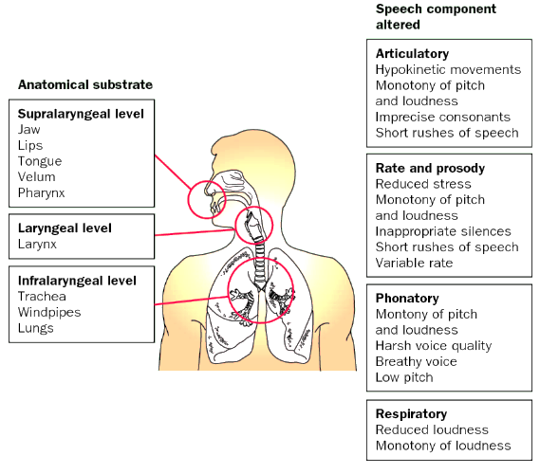

## **7.3 Previous Researches**

Many studies had been conducted and found changes in acoustic characteristics of speech that correlate with Parkinson disease. These studies focus on few major topics:

1. Speech tests – what kind of speech is required for detection of Parkinson symptoms.
2. Acoustic features – what kind of parameters can be extracted from the speech signal that indicate Parkinson disease.
3. Classification algorithm – which way to use the acoustic features values in order to achieve best classification results.

A comprehensive description of acoustic features that can manifest Parkinson in the voice is described in [‎8] and are described in Table 1. In this study, these features were extracted from database of 31 people, 23 with PD and 8 healthy with 195 overall records of sustain vowel [‎8].

|  |  |  |
| --- | --- | --- |
| No. | Feature | Explanation |
| 1 | Fo (Hz) | Average vocal fundamental frequency |
| 2 | F0-high (Hz) | Maximum vocal fundamental frequency |
| 3 | F0-low (Hz) | Minimum vocal fundamental frequency |
| 4 | Jitter (%) | A measure of variation in fundamental frequency - Inconsistency of period-to-period. |
| 5 | Jitter (Abs) | Fundamental frequency variation in cycle-to cycle |
| 6 | RAP | Comparative Perturbation. |
| 7 | PPQ | Perturbation Quotient of Period in 5-point. |
| 8 | Jitter: DDP | Normal distribution of jitter |
| 9 | Shimmer | A measure of variation in amplitude – Amplitude of peak-to-peak. |
| 10 | Shimmer(dB) | A measure of variation in amplitude – Amplitude of peak-to-peak in terms of decibels |
| 11 | Shimmer: APQ3 | Quotient of amplitude perturbation in 3-point |
| 12 | Shimmer: APQ5 | Quotient of amplitude perturbation in 5-point |
| 13 | MDVP: APQ | A measure of variation in amplitude |
| 14 | Shimmer: DDA | A measure of variation in amplitude |
| 15 | NHR | Ratio of Noise-to-Harmonic |
| 16 | HNR | Ratio of Harmonic-to- Noise |
| 17 | RPDE | A nonlinear dynamical complexity measure |
| 18 | D2 | A nonlinear dynamical complexity measure |
| 19 | DFA | Signal fractal scaling exponent |
| 20 | spread1 | A nonlinear measure of fundamental frequency variation |
| 21 | spread2 | A nonlinear measure of fundamental frequency variation |
| 22 | PPE | A nonlinear measure of fundamental frequency variation |

Table 1 – List of Acoustic Features

The acoustic features were processed using the following machine learning classifiers: Support Vector Machine (SVM), K-Nearest-Neighbor (KNN) and discrimination function based (DBF) classifiers [‎8].

The classifiers performance was evaluated using different methods [‎8]:

* K-fold cross validation.
* Holdout cross validation.
* Holdout method.
* Random subsampling methods.

SVM classifier obtained (91.04%) of accuracy, KNN classifier (93.82%) and DFB classifier (82.2%). KNN classifier showed best performance results [‎8].

An additional machine learning algorithm approach was studied in [‎9]. A list of the selected acoustic in this research features is described in Table 1. These features were tested on a database of 31 people, 23 with (PD) and 8 healthy with 195 overall measurements from all the subjects [‎9].

The acoustic feature data was processed using the following machine learning classifiers and methods of improvements: Bagging, boosting, random forest, rotation forest, random subspace, support vector machine, multilayer perceptron and decision tree [‎9].

The classifier performance was evaluated with different methods [‎9]:

* Accuracy (ACC).
* Precision.
* Receiver Operating Characteristics (ROC).
* Matthew’s correlation coefficient (MCC) is used to measure the performance.

The accuracy result of different classifiers: bagging (87.7%), boosting (91.3%), random forest (90.3%), rotation forest (93.3%), random subspace (90.3%), support vector machine (79%), multilayer perceptron (88.7%), and decision tree (85.6%) [‎9].

It was observed that the random forest provided overall accuracy of 90.3%, precision 90.2%, Mathew’s correlation coefficient values of 0.73 and ROC values 0.96 which is better in comparison to all other machine learning based approaches [‎9].

To conclude, the most affective classifiers used in these studies are: KNN, SVM, rotation forest, random forest. Both extract the following features: Fo (Hz), Fhi (Hz), DFA, spread 1, spread 2, D2, PPE, HNR, DFA, shimmer: DDA, RPDE, D2, and PPE, jitter.

## **7.4 Prominent Acoustic Characteristics**

### **7.4.1 Jitter**

Jitter is a quantified measurement describing variation of gluteal pulses and defined as variation in the period of each successive cycle of vibration. The voices of patients with pathologies often have a higher percentage of jitter. The values for Jitter can be measured in different parameters: absolute and relative [‎10]:

1. Jitter absolute is the average absolute difference between consecutive periods, expressed as [‎10]:

$$jitter\left(absolute\right)=\frac{1}{N-1}\sum_{i=1}^{N-1}{\left|T_{i}-T_{i-1}\right|}$$

*Equation 1*

Where, $T_{i}$ is the extracted glottal period lengths and $N$ is the number of extracted glottal periods.

1. Relative Jitter is the average absolute difference between consecutive periods, divided by the average period. It is expressed as a percentage [‎10]:

$$jitter\left(relative\right)=\frac{\frac{1}{N-1}\sum_{i=1}^{N-1}{\left|T_{i}-T_{i-1}\right|}}{\frac{1}{N}\sum_{i=1}^{N}{T_{i}}}×100$$

*Equation 2*

### **7.4.2 Shimmer**

Shimmer is quantified measurement describing cycle-to cycle temporal changes of the amplitude of the vocal fold vibration; contributes to the perception of a rough or harsh voice quality. The values for Shimmer can be measured in different parameters [‎10]:

1. Shimmer (dB) is expressed as the variability of the peak-to-peak amplitude in decibels, i.e. the average absolute base-10 logarithm of the difference between the amplitude of consecutive periods, multiplied by 20 [‎10].

$$shimmer\left(dB\right)=\frac{1}{N-1}\sum_{i=1}^{N-1}{\left|20*\log\left(\frac{A_{i+1}}{A_{i}}\right)\right|}$$

*Equation 3*

Where, $A_{i}$ is the extracted peak-to-peak amplitude and $N$ is the number of glottal periods.

1. Shimmer absolute is defined as the average absolute difference between the amplitudes of consecutive periods [‎10]:

$$shimmer=\frac{1}{N-1}\sum_{i=1}^{N-1}{\left|A_{i}-A_{i+1}\right|}$$

*Equation 4*

### **7.4.3 Harmonic to Noise Ratio**

HNR, NHR and SNR are used as a measurement of the quality of the voice and are expressed in dB. Speech signals in Parkinson's patients are commonly corrupted with additive noise. The energy of additive noise is a parameter used as part of those parameters to diagnose Parkinson's disease. HNR, NHR and SNR are mathematically defined as [‎10]:

$$HNR=10\log_{10}\left(\frac{En_{s\left(k\right)}}{En_{w\left(k\right)}}\right)\left[dB\right]$$

*Equation 5*

$$NHR=10\log_{10}\left(\frac{En_{T\left(k\right)}}{En_{w\left(k\right)}}\right)\left[dB\right]$$

*Equation 6*

$$SNR=10\log_{10}\left(\frac{En_{s\left(k\right)}}{En_{T\left(k\right)}}\right)\left[dB\right]$$

*Equation 7*

Where: $En_{s\left(k\right)}$ is the energy of the periodic component of speech generated by vocal folds and $En_{w\left(k\right)}$ is the energy of the noise component of speech generated by airflow from lungs and $En_{T\left(k\right)}$ is the total component of speech. For Parkinson's patients $En_{w\left(k\right)}$ increases due to an imperfect glottal closure. There are several ways to separate speech and noise signal: analysis in time domain, frequency domain, using wavelets or cepstral analysis [‎10].

### **7.4.4 Pitch**

Pitch is defined as the rate of vibration of the vocal folds and corresponds closely to the fundamental frequency ($F_{0})$. The sound of the voice changes as the rate of vibrations varies. As the number of vibrations per second increases, so does the pitch, and the voice would sound higher. Slower rates elicit lower pitches, or deeper voices.

A commonly used method to estimate pitch is based on detecting the highest value of the autocorrelation function $\text{R(}τ)$ in the region of interest, which is calculated by [‎11]: $$\text{R(}τ)=\frac{1}{N}\sum_{n=0}^{N-1}{x\left(n\right)x\left(n+τ\right)}$$

*Equation 8*

Where: $x\left(n\right)$ is the speech signal, $τ$ is the lag number, $n$ is the time for a discrete signal and $N$ is the section length being analyzed.   
The characteristic of $\text{R(}τ)$ is that it has a large value when $x\left(n\right)$ is similar with $x\left(n+τ\right)$. if $x\left(n\right)$ has period of $P$, then $\text{R(}τ)$ returns largest values when $τ=lP$, for $l=0,1,2$ while other peaks of $\text{R(}τ)$ usually decrease as $τ$ increases. Therefore, we can estimate the pitch period $P$ from the location of the peak at [‎11].

For a nonstationary signal, such as speech, it is reasonable to define a short time autocorrelation function, which operates on short segments of the signal [‎11]:

$$\text{R(}τ)=\frac{1}{N}\sum_{n=0}^{N^{'}-1}{[x\left(n+l\right)w\left(n\right)][x\left(n+τ+m\right)w(n+m)}] 0≤m≤M_{0}$$

*Equation 9*

Where $w\left(n\right)$ is a window function, $N^{'}$ is the number of signal samples used in the computation of $\text{R(}τ)$, $M_{0}$ is the number of autocorrelation points to be computed, and $l$ is starting the index of the frame. For pitch detection applications $N^{'}$ is generally set to the value [‎11].

In some cases, the peak located at $τ=2P$ is larger than that located at $τ=P$. Then, a half pitch error occurs. For emphasizing the true peak, an analysis of the lags is conducted, with aim of identifying whether the detected peak is a multiply of the real period [‎11].

Also, there are cases when the formant structure effects on the detailed shape of the short time autocorrelation function. This happened when the fundamental frequency is not the strongest component due to overlap in the range of values ​​of the fundamental frequency and the first formant. Hence, the 2-8 harmonic components can be stronger than the fundamental component. Center-Clipping of speech is a pre-processing technique that aimed to overcome these harmonic errors. This technique is defined by the relation between input $x\left(n\right)$ and [‎11]:

$$y\left(n\right)=clc(x\left(n\right))\left\{ \begin{aligned}\left(x\left(n\right)-C_{L}\right), x\left(n\right)≥C_{L} \\ 0, \left|x\left(n\right)\right|<C_{L} \\ \left(x\left(n\right)+C_{L}\right), x\left(n\right)≤C_{L}\end{aligned}\right.$$

*Equation 9*

$C_{L}$ is the clipping threshold. Generally, $C_{L}$ is about 30% of the maximum magnitude of the signal.

# **8. Methods**

The overall analysis process of each record is summarized in the following scheme:

* Voice Activity Detection algorithms (VAD) is used to identify Voice\Unvoiced\Silence segments in speech. The following features are used as part of the identification process as thresholds values: Zero Crossing, F0, autocorrelation coefficient (R0), LPC prediction error, Energy value and STFT maximal amplitude.
* Division of the audio signal into frames.
* Extraction of features for sustain vowel and continuous speech for each frame or per the entire record. This process includes classical and special parameters, as part of our research, aiming to evaluate the periodic nature of the signal and to quantify disarrayed frame.
* Statistical analysis is performed on the results (such as: standard deviation, minimum, maximum and their ratio and more), if needed.
* Train Machine Learning algorithms (SVM and KNN) with aim to obtain high classification rate.

This entire process is run through system of greater functions as illustrated below:

Now, these functions are discussed and presented.

## **8.1 Main Script ("MainRun")**

This is the primary and main function where all-important values that indicate what type of run is needed, are initialized. This include:

1. Numeric variable that states the kind of statistical analysis is needed (Named "Ftr_statList")
2. Numeric variable that states the number of features to run and their indexes (Named "FtrListRUN"). These features will be extracted from the record.
3. String variable (Named "SaySTR") that state the type of saying – Counting (CNT), long AH (MPT), Spontaneous speech (SPONT), Pa-ta-ka (PATAKA), picture descripting (PIC_DESC) or Elef-Haim reading passage (T_ILND).
4. Additional variables that include: the size of the frame, the size of the overlap between frames, option to normalize the data if the feature-matrix exceeds 1 dimension.

This main script has the responsibility for calling function "Create Feature Matrix" that calculates the predetermined features and "Machine Learning" function that runs KNN and SVM machine learning classification algorithms. The results of the classification are then imprinted into text file, that mainly includes the number of PD speakers, HC speakers, the accuracy rate, specificity and sensitivity values. This text file is saved in designated folder.

## **8.2 Analyze Records ("Create Feature Matrix")**

This is a secondary function with main role of calculating features for the appropriate type of records, according to type of saying.

Firstly, this function runs "Process Excel" function that returns file names and other necessary information (such as: the ID of speaker, gender, age and label) of all records that are compatible to the needed type of saying. Then, a loop on all of those speakers is run. For each, the audio is first read, analyzed by "VAD" function and features are extracted by "CalcFeatures" function. Then, statistical parameters calculation is performed by "CalcStati" function. All those features are imprinted into a text file along with other useful information such as: speaker's ID, the record's name, the speaker's statues, type of saying and frame number.

Now each of these functions is described in a broad manner.

### **8.2.1 Extract Database ("Process Excel")**

This is a tertiary function with main role of extracting information about the database from an Excel file. This function's input is the excel file name and the type of saying text (that is being initialized in the main run function) and returns the following information about all files who answer this text condition:

1. "WavFileNames" - The directories and file names that are defined as vectors of characters that include the file extension. Used for reading the audio files.
2. The number of files that are found for type of text.
3. Additional information about the speaker: Speaker ID, age, gender, pathology and pathology code (1 for PD and 3 for HC).

The excel file is loaded by using MATLAB built csvimport function.

### **8.2.2 Voice Activity Detection ("VAD")**

Implementation of detection algorithm of Voice\Unvoiced\Silence segments in speech signal based on threshold values. Figure 18 represents the results of applying this self-implemented algorithm on a speech signal. The following features were extracted from each frame and used as thresholds for the identification process, as introduced by literature review:

1. Zero Crossing (Colored yellow) - The number of zero-crossings refers to the number of times speech samples change sign in a given frame. This short term zero crossing rates tend to be higher in unvoiced regions than of voiced regions and this is due to appearance of high frequencies in unvoiced/noise frames and appearance of frames low frequencies in voiced [‎12].
2. Energy values (Colored Blue) - For voiced segments the energy amplitude is higher than of unvoiced segments and much higher of silence [‎12].

Additionally, due to low accuracy level in identifying unvoiced segments, the following parameters were added:

1. F0 (Colored brown) – Voiced speech contains a strong fundamental frequency with its harmonics. Hence, the voiced segments have pitch values in the range of 80-400 Hz when usually unvoiced segments have much higher or lower values.
2. Autocorrelation coefficient (Colored Green) – The premise of using this feature is that closely spaced samples in voiced frames are often highly correlated, while samples in unvoiced frames are less correlated, and noise is the least. Therefore, we expect to receive lowest values of autocorrelation coefficient for unvoiced or noise frames and highest for voiced frames.
3. LPC prediction error (Colored Orange) – LPC is a method that models speech using linear regression. Thus, for voiced segments, LPC will be able to model speech accurately and therefore LPC prediction error will be low. For unvoiced segments, LPC will be less able to model accurately and therefore will create larger prediction error. The highest error will be presented in silence segments.
4. STFT maximal amplitude (Colored Purple) - The spectrum of a voiced segments contains more energy than of silence or unvoiced segments, Therefore, we expect to receive highest energy in spectrum for voiced segments, and lowest for silence segments.

The results are colored red - Returns '1' for voiced segments, '0.5' for unvoiced segments and '0' for silence.Figure 3 and 4 illustrate this algorithm results:



Figure 3 – VAD algorithm results for sustain vowel \Ha\

Characteristics



Figure 4 – VAD algorithm results for counting one-to-ten in Hebrew

Characteristics

As a validation for this algorithm, Figure 5 displays the results for 'shemesh' (Sun in Hebrew) type of saying. This word contains voiced and unvoiced parts: 'Sh' is unvoiced, 'E' and 'Me' are voiced, and as can be seen, all were correctly classified.

Figure 5 – VAD algorithm results for \Shemesh\

Characteristics



### **8.2.3 Feature Extraction ("CalcFeatures")**

This function is responsible for calculating different features for a record, according to the feature's index initialized in the main function. The features are separated by switch cases.

All features and their accompanied functions are presented, in accordance to their case-index in this function:

*8.2.3.1 Vector to Frames*

In each feature case, the function vec2frame is run. This function is responsible to divide the signal into frames, with possible overlap, if chosen. Speech is considered a non-stationary signal. To achieve stationarity, the signal is divided into frames with the assumption that properties of the speech remain invariant (stationary) for 5-100 msec.

Figure 6 illustrates the results of self-written function that preform division of the signal into frames. In our algorithm the size of each frame is 0.05 sec, with zero overlap. This size of frame was chosen in order to be able to calculate specific features that obligate existence of at least 2 periodic peaks in the signal (such as: Jitter). Moreover, in order to shorten running time, zero overlap was chosen.



Figure 6 – Plot of \Ha\ Audio Signal and First Four Frames

Characteristics

*8.2.3.2 HNR, NHR and SNR (Case 1)*

An algorithm for evaluating HNR, NHR and SNR in frequency domain was implemented (The mathematical presentation and process are summed at section 7.4).

By using MATLAB function periodogram on each frame, the power spectral density estimation is obtained when the analysis is performed up to 3000 Hz. The spectrum contains two types of regions: area of the peaks that represents the harmonic parts of spectrum and the area between them that is assumed to be noise components (Figure 7). The algorithm separates the speech spectrum to harmonic and noise parts. Each were summarized and used to measure HNR, NHR and SNR per frame. The result of the algorithm is average value of HNR, NHR and SNR of all frames.

**(a)**

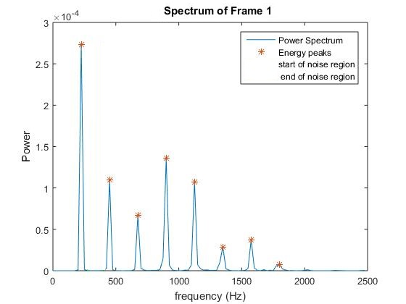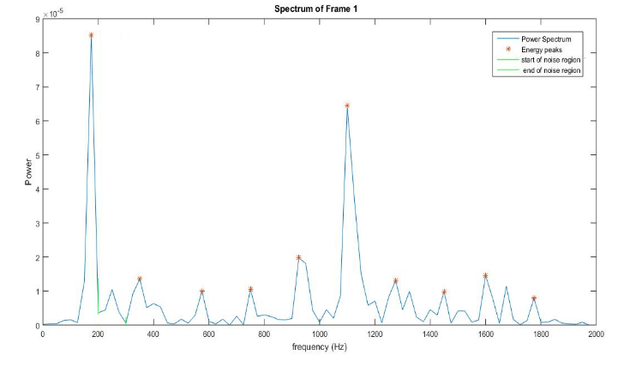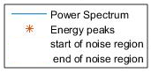

**(b)**

Figure 7 - Power Spectrum and its close-up on harmonic and noises part of HC (a) and PD (b) speakers.

Characteristics

Harmonic Part

Noise Part

Harmonic Part

Noise Part

Harmonic Part

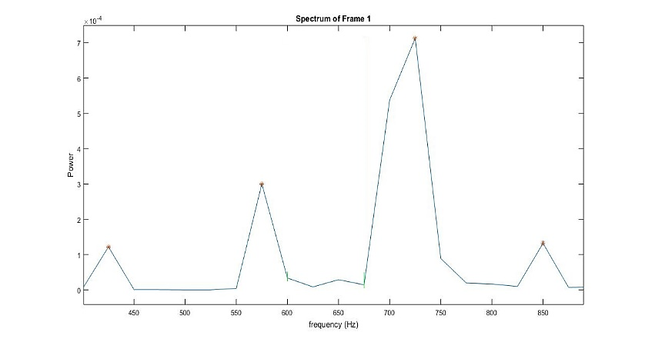

Noise Part

Harmonic Part

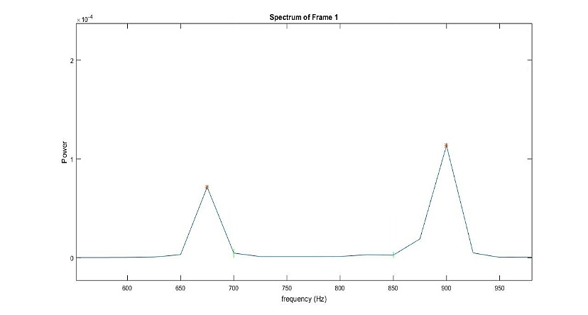

Harmonic Part

Noise Part

Harmonic Part

We expect that for Parkinson diseased speaker, the spectrum will show higher noise levels with deteriorated harmonic structure even at lower frequencies (Figure 7b). Which affects HNR, NHR and SNR values and can be used to distinguish diseased speaker from healthy one. In addition, in order to improve identification rate, the limitation of the frequency axis in spectrum that is being analyzed, can be changed and its effect can be examined.

*8.2.3.3 Pitch*

First, with intention of improving the accuracy of pitch estimation, clipping threshold algorithm was implemented on each frame (Figure 8). This method aims to reduce the effect of the detailed structure of the signal on the short time autocorrelation function. (The Mathematical presentation and process are summed at section 7.4).

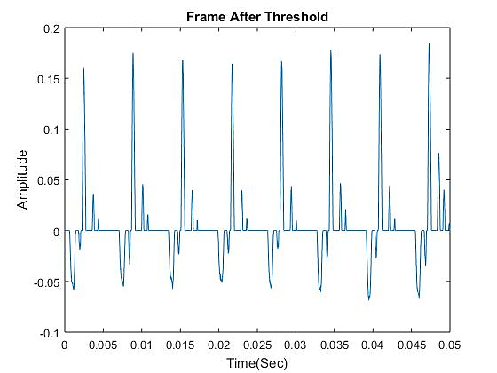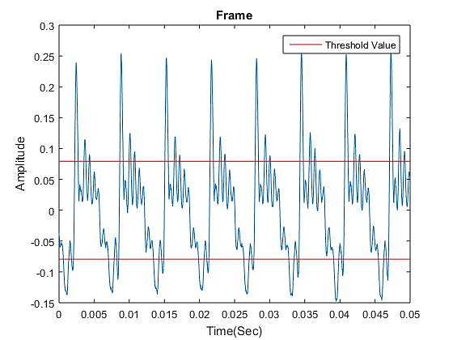

Figure 8 – Original frame (a) and the frame after using Clipping threshold algorithm (b).

Characteristics

**(a)**

**(b)**

Then, an algorithm of pitch estimation was implemented. The algorithm is based on detecting the highest peak of the autocorrelation function of each frame in the audio signal (Figure 9). The pitch is obtained by dividing the sampling rate in the sampling number of the highest value (Their Mathematical presentation and process are summed at section 7.4).

In some cases, the highest peak represents a harmony of the pitch period, then a half pitch error occurs. Therefore, a threshold value is defined, which is equal to the location of the maximum multiplied by a constant, in a range of 0.8 to 1.2. If the sampling number of the second highest maximum multiplied by a period number (2 or 3) is within that range, it is assigned as the pitch period.

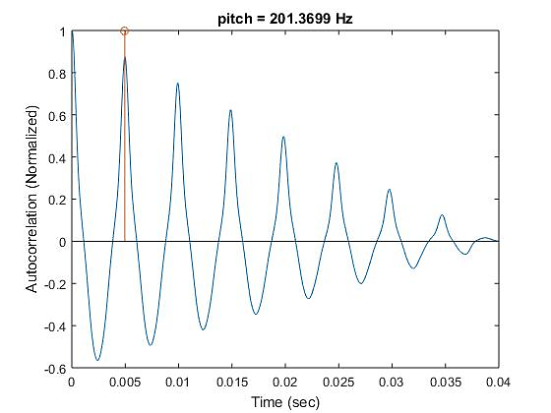

Figure 9 – Frame's Autocorrelation. The marked line represents the highest value of the autocorrelation, the pitch.

Characteristics

Using the algorithm described above is still error prone. Pitch detection is very important for many speech processing algorithms. An inaccurate pitch value can lead to noisy and undependable features measurements. Therefore, to improve the performance, a median filter is used. The output of the algorithm is the median pitch value of all frames.

Validation of this algorithm is done by comparing the pitch values, the shape of the pitch curves and the median pitch to Praat software, an advanced and common speech analysis tool. Figure 10 illustrated the results of pitch of each frame by our algorithm (Left) and Praat software (Right).

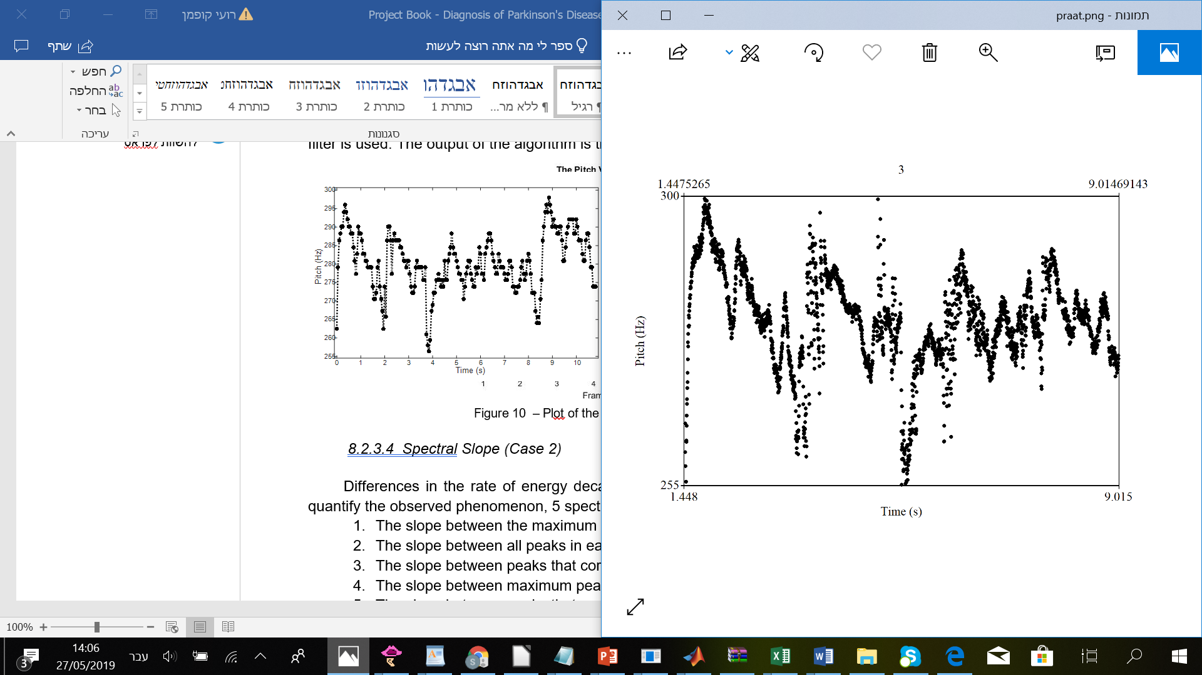

Figure 10 – Pitch per frame by Pitch algorithm (Left) and by Praat software (Right)

*8.2.3.4 Spectral Slope (Case 2)*

Differences in the rate of energy decay in each frame were noted. thus, in order to quantify the observed phenomenon, 5 spectral slope parameters are calculated:

1. The slope between the maximum peak to the minimum peak (Figure 11).
2. The slope between all peaks in each frame.
3. The slope between peaks that correlate to the pitch of all frames.
4. The slope between maximum peaks of all frames.
5. The slope between peaks that correlate to the pitch to the last peak in each frame.

The spectrum of PD patients was observed having much faster rate of energy decay compared to HC patients. Therefore, we expect that for PD patient have a higher slope.

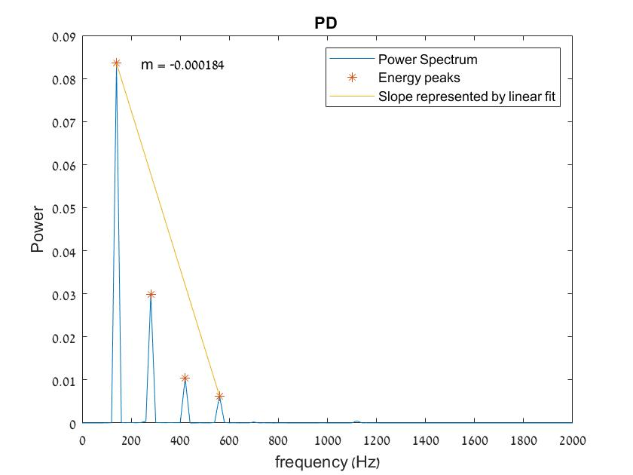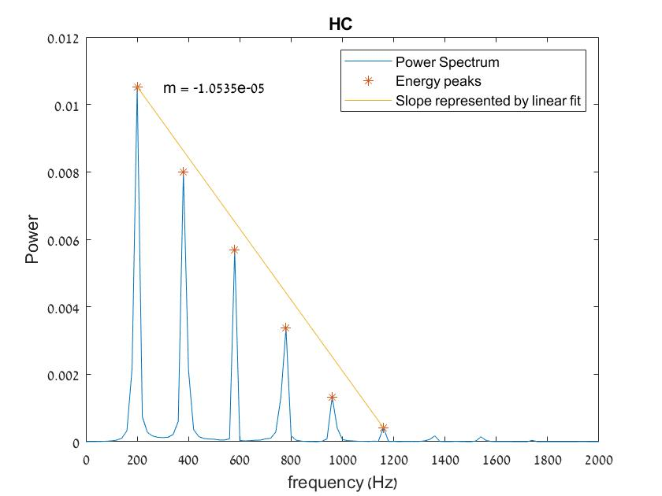

Figure 11 – The slope of maximum and minimum peak in HC (Left) and PD (Right) speakers.

*8.2.3.5 Speech Rate (Case 3)*

An algorithm for speech rate evaluation was implemented. Using detection algorithm of Voice\Unvoiced\Silence segments on recordings of continuous speech signal.

Three types of speech rates are calculated:

1. Duration of voiced segments divided by the duration of all speech signal.
2. Duration of unvoiced segments divided by the duration of all speech signal.
3. Duration of voiced segments divided by the duration of unvoiced segments.

The speech rate measurements used to evaluate the subject’s ability to repeat a consonant–vowel combination. PD patients have demonstrated short phrases, rushes of speech, inappropriate pauses and defects in the ability to make rapid articulator movements. Therefore, we expect a difference in speech rates values ​​between healthy patients and PD patients.

*8.2.3.6 Finding Periodic Peaks in The Speech Signal (FindPeaks)*

To be used for several features, algorithm of finding periodic peaks in the signal was independently implemented.

First, based on cross-correlation, a window that consists about one period (according the pitch of the frame) of the vocal cords' vibration is created around the maximal peak of each frame, as figure 12 illustrates:



Figure 12 – Plot of Chosen Window

Then, this one period window runs on top of the frame, multiplies index by index and sums the values. This process is repeated for each moving unit, stepping one unit at the time, as illustrated in Figure 13.



Figure 13 – Plot of Running Window at different index



The resultant function of this multiplication is referred to by S' (Figure 14a). The indexes of the peaks in 'S' are adjusted to the peaks of the signal, by adding to these indexes, the location of the maximal peak in the frame. Moreover, since it still sometimes shows inaccuracy, each peak in the signal is adjusted to search the maximal peak around it (Figure 14b).

Figure 14 - Results of "FindPeaks" algorithm of PD subject



**(a)**

**(b)**



*8.2.3.7 Jitter and Shimmer (Case 4 and 5, respectively)*

Algorithms of Jitter and Shimmer features extraction were independently implemented. These algorithms are based on "FindPeaks" algorithm mentioned above. Jitter is defined as the change in glottal period along the signal (The change in the differences between cycles duration) and shimmer is defined as the change in periodic peaks' amplitude. Their mathematical presentation is mentioned in section 7.4.

**(a)**

Speech signal of Parkinson's disease is less periodic and stable than of healthy subject. Accordingly, due to decreased muscle control of the vocal cords in PD speaker, they have much higher probability to display greater variations of periods and amplitudes, as illustrated in Figure 15.

Figure 15 - Jitter and shimmer differences between healthy (a) and diseased (b) speakers

**(b)**



Period

Period

Shimmer



**(a)**

The accuracy of these algorithms is based on identifying the correct pitch of each frame, else it can create a wrong-length window at "FindPeaks" algorithm and therefore finding wrong peaks, which results in manipulation of the final results.

The calculation of these values excludes distorted frames, meaning frames with no visual periodic nature. This exclusion condition is done using threshold value of the amplitude of autocorrelation function. Figure 16 illustrates distorted frames with low autocorrelation amplitude which leads to wrong identification of peaks in the signal.



Figure 16 - Plot of Distorted Frames



In addition, in these features, the speech signal is assumed to be constant and stable. But, long sustain vowel contains the start and the end of the speech that are considered unstable and aperiodic segments for both HC and PD, due to lack of lung pressure and lack of air in the lungs. Therefore, the calculation disregards those sections.

*8.2.3.8 Special Frames – In Frequency Domain (Case 8)*

Special frames were identified in the frequency domain. The main purpose of these features is to identify frames that have much higher probability to be found in PD patients than healthy patients, to count their occurrences and use it as indicator of the disease. This function returns 5 parameters that characterized visible changes between healthy patients and PD patients.

After examining multiple frames, it has been noted that for most of the healthy speakers the peak in the spectrum correlated with the pitch has high power value compared to other peaks in the spectrum, while for Parkinson's speakers, the power value of the peak that correlated to the pitch was much lower compared with other peaks in the spectrum. Based on this observed phenomenon, 4 parameters are calculated.

1. Ratio between the number of special frames to the total number of frames. The special frames are identified based on finding pitch peak (the peak that is correlated to the pitch) in the spectrum by using the pitch value from the autocorrelation function. Then, a threshold is defined of about 50% of the maximum power of the frame (This percentage can be changed, and its effect on the identification rate can be examined). If the power of the pitch is not the maximal in the spectrum and it is less than the set threshold, the frame is assigned as special frame (Figure 17).
2. Ratio between the number of special frames to the total number of frames. Special frame is identified by frame with lower power of pitch peak than of at least 2 preceding peaks to its right up to the maximum peak (Figure 17, right plot).
3. Ratio between the number of special frames to the total number of frames. Special frame is identified by frame with lower power of pitch peak in 20% than of at least 3 preceding peaks to its right up to the maximum peak.
4. The mean and std of the ratio between the power of the pitch peak and the maximal peak in each frame.

In cases when the peak that correlated to the pitch is not the maximum peak, differences in the distance between those peaks were noted. Therefore, the calculate parameter is:

1. The ratio between the number of special frames to the total number of frames. Special frame is identified by maximum peak placed in the third harmony of the pitch peak and higher (Figure 17, right plot).

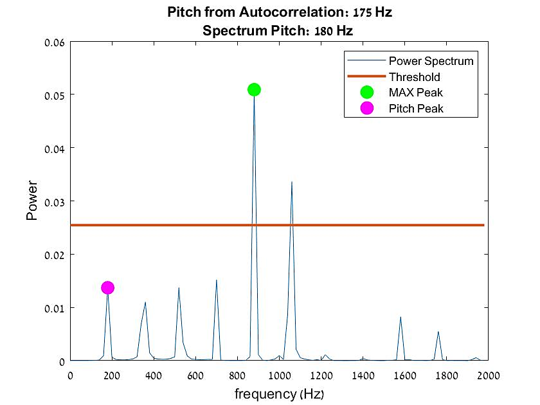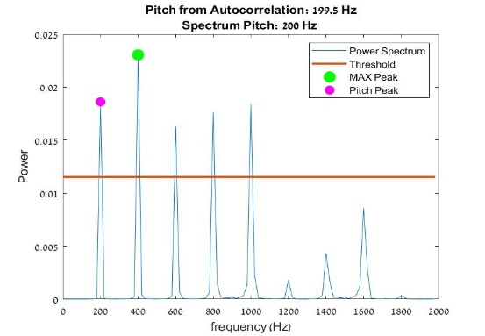

Figure 17 – Normal frame (Left) and Special frame (Right).

*8.2.3.9* *Special Frames – In Time Domain (Case 9)*

As part of our research, a function was written aiming to identify non-periodic frames and to quantify distortion level of each record. These parameters were invented by visualizing and investigating possible changes that characterize distorted frames in time domain. This algorithm counts the number of special frames with the expectation to find those parameters domination in PD speakers and insignificant to zero-count in HC speaker. This assumes that PD speech signal is less periodic and stable in constant segments in sustain vowel due to lower muscle control.

This function returns 7 values and sub-features:

* 1. The number of frames in each record with glottal periods deviation above 30% compared to median pitch of the record. This aims to represent an unstable pitch.
  2. The number of frames in each record with glottal periods deviation above 30% compared to pitch of the frame. Figure 18 illustrates this kind of irregularity. It is possible to see a change in the period in the middle of the frame.



Figure 18 – Deviation of Period above 30%

* 1. The number of frames with lower autocorrelation amplitude than threshold value of 0.5. Figure 16 illustrates this kind of irregularity.
  2. The number of frames with low number of peaks per frame. Figure 19 illustrates this kind of irregularity.



Figure 19 – Frame with Low Number of Peaks

* 1. The entropy of the ratios between the expected number of peaks in each frame, to the existing number of peaks. This feature quantifies the number of missing peaks.
  2. The total number of special frames in each record (sum of values 1-4).
  3. The ratio between the number of special frames to the total number of frames in a record.

This function also includes the possibility for automatic saving of the plots of these special frames which enables visual examination.

*8.2.3.10 Features of 'S'* *(Case 8)*

As part of "FindPeaks" function, a moving window is created that is multiplied with the signal and summed at each sample unit. Thus, a smoothed presentation of the original signal is created (as shown in Figure 14) that represents information about the periodic nature of the signal.

An assumption was made that creating new features particular to this smoothed function ('S') could add new information about irregularity and un-periodic nature that is expected from PD speech signal. This assumption is based on the possibility that this function produces better signal to analyze and extract features from. As part of the code, 'S' function is created, and then the peaks are found, as shown in Figure 20.

Figure 20 – Original Signal (Left) and its Smooth Presentation (Right)



Then, 5 different features are extracted with aim to characterize noisy signal. Those features return value for each frame:

1. Sum of each glottal period in 'S' (The energy of each glottal period). Then, finding the differences between them, and calculating the entropy of these values. It was assumed that in periodic signal (healthy) the differences between the glottal periods is negligible and will remain constant while in PD the differences are expected to be more significant.
2. DTW (a MATLAB function that calculates distance between two numeric series of different sizes. This distance finds the minimal path in a distance matrix) of the first and last glottal periods. This feature assumes that in less periodic signal, the distance between these two periods will be higher.
3. Entropy of the differences between the peak's amplitudes of each frame.
4. Mean differences between the peak's amplitudes of each frame.
5. Difference between the lengths of each glottal period.

This function excludes distorted frames with low amplitude of autocorrelation, and frames with lower number of peaks than 3. In addition, in these features, the speech signal is assumed to be constant and stable, hence the start and end of the speech are disregarded.

*8.2.3.11 Lengths Statistics (Case 9)*

This function is used to analyze continuous speech and is created based on understanding that articulatory rate, pause time and organization of speech timing in Parkinson's disease is different than of HC speaker. As part of its functionality, VAD function is called and its results are used to calculate 6 values and features (which makes these features very sensitive to the performance of VAD):

1. Standard deviation of the vector of lengths of voiced segments in a record.
2. Standard deviation of the vector of lengths of unvoiced segments in a record.
3. Standard deviation of the vector of lengths of silence segments in a record.
4. Entropy of the vector of lengths of voiced segments in a record.
5. Entropy of the vector of lengths of unvoiced segments in a record.
6. Entropy of the vector of lengths of silence segments in a record.

*8.2.3.12 Gradient and STD of Pitch and RMS (Case 10 and 11, respectively)*

PD patients suffer from reduced vocal loudness and vocal decay. Hence, when a patient is asked for sustain vowel, gradual fading in loudness can be seen, which is characterized by higher rate of pitch and energy decay comparing to HC speaker. In order to quantify those changes, gradient and STD of those features are calculated. The gradient of a linear equation is extracted using MATLAB ployfit function (Figure 21).

Figure 21 – Pitch gradient (a) and RMS gradient (b) of HC and PD speakers.

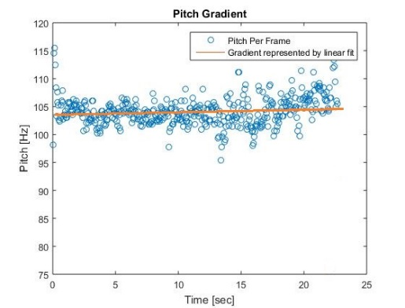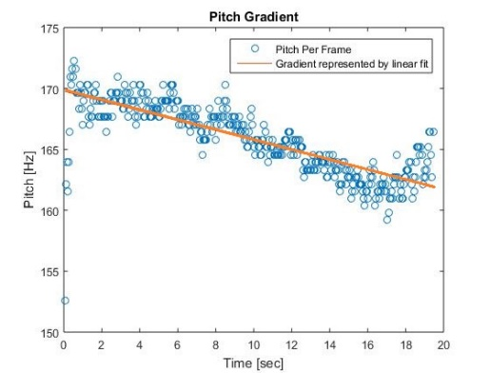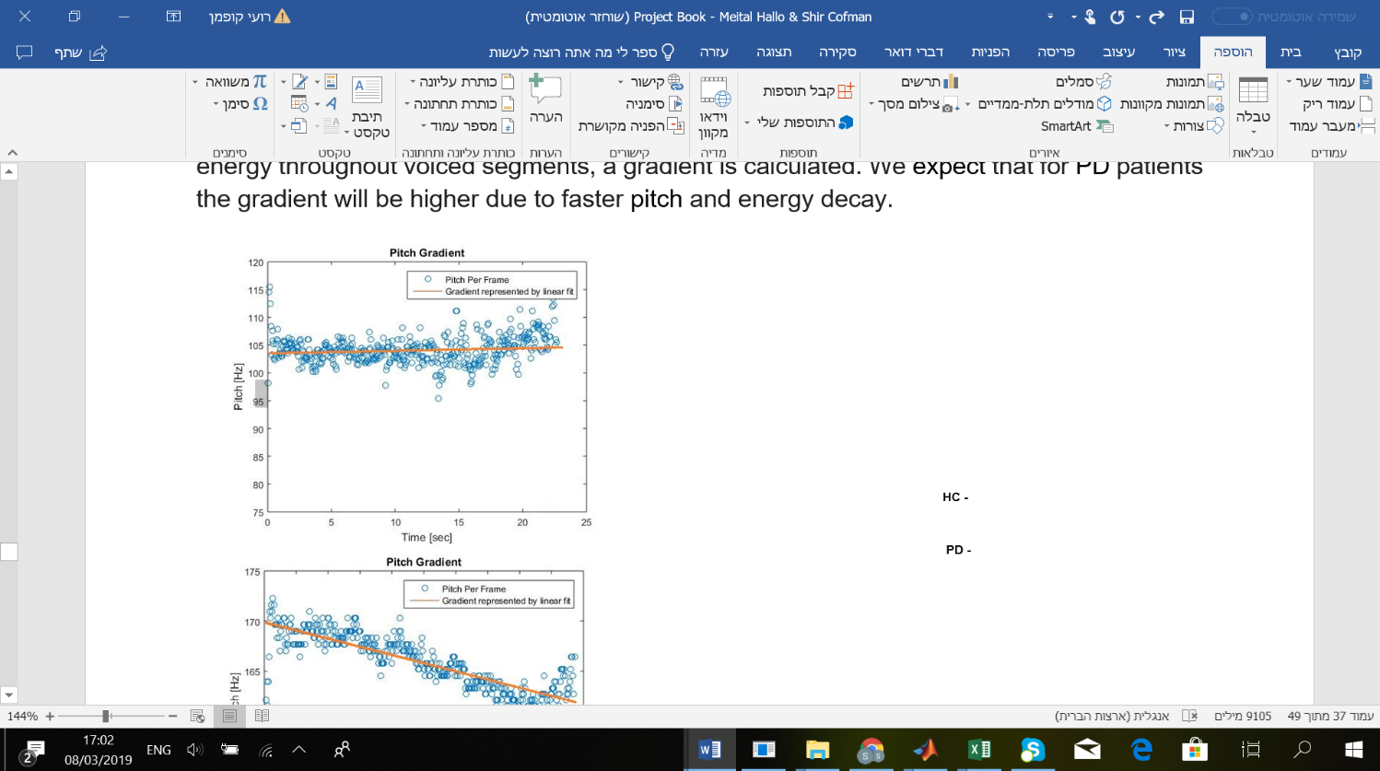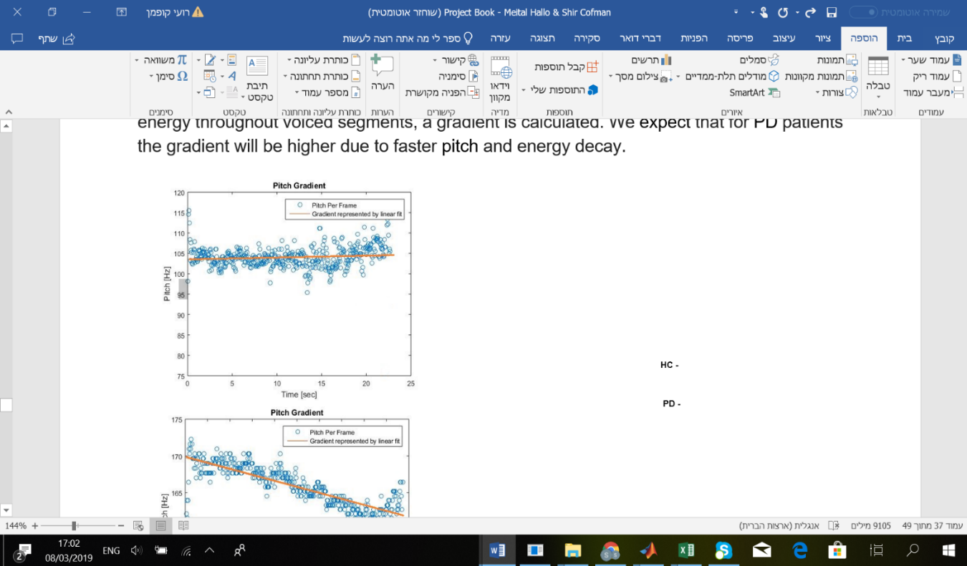

**(a)**

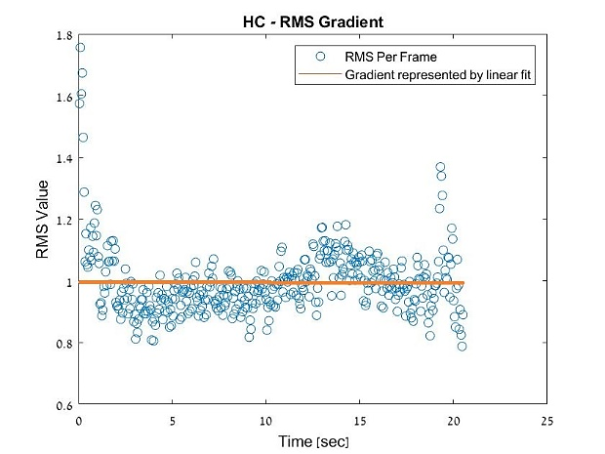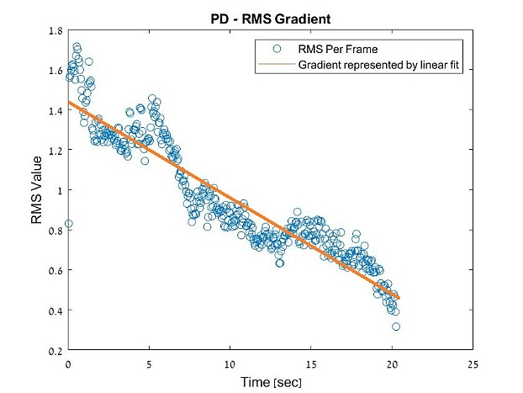

**(b)**

*8.2.3.13 Autocorrelation Amplitudes Per Frame and Per utterance   
 (Case 12 and 13, respectively)*

This function is based on the amplitude of the period of each frame in short time autocorrelation function. This amplitude represents how much the signal is periodic and correlative. Due to the less periodic nature of PD speaker, autocorrelation amplitude is expected to be lower than of HC speaker and show greater variability. The autocorrelation amplitude per frame is run through smoothing filter with aim of reducing the potential of mal-function of the Pitch algorithm. In addition, it neglects the starting and ending of the speech.

Figure 22 illustrates autocorrelation amplitude per frame for HC and PD speakers. It is possible to see that PD speaker show greater variability and lower mean value .



Figure 22 – Autocorrelation Amplitude Per Frame of PD and HC Speakers.

Additional option is extraction of autocorrelation amplitude of the entire utterance. This method allows extraction of additional and more specific values of the autocorrelation results:

1. Amplitude of the first peak (Figure 23a).
2. Amplitude of the second peak.
3. The difference between the amplitudes of the forth and first peaks.
4. The sum of the difference between the amplitudes of 6 first peaks.
5. The sum of the difference between the periods of 6 first peaks.
6. The slope of the autocorrelation result, as illustrated in figure 23b.

Figure 23 – Zoom On the 6 First Peaks of Autocorrelation (a) and its Slope (b)

Characteristics

**(a)**

**(b)**



*8.2.3.14 Speech Entropy (Case 14)*

In this feature, entropy of each frame is calculated with aim to express disorganization of the signal. This is based on the understanding that PD speech signal is less organized and clear than of HC speaker and accordingly PD speakers are expected to show higher values of entropy. Figure 24 displays the changes between PD and HC speakers.



Figure 24 – Entropy Per Frame of PD (Left) and HC (Right) Speaker

This feature is applied on the stable and constant segments of speech in order to reduce the effect of the aperiodic segments in the start and end of the sustain vowel.

### **8.2.4 Calculate Statistics for a Feature-Vector Per utterance ("CalcStati")**

This function is responsible for returning for each feature-vector of one record, a statistical value or values. All statistical options are separated by switch case according to index that is initialized in the main run function named "Main Run".

The statistical analysis includes min, max, standard deviation, median, mean, entropy and optional parameters max-min, max-median and max-mean. These values return to the secondary function – "Create Feature Matrix", as "new" features that enter machine learning classifiers. If a feature returns single value for the entire record, this function can also do nothing, meaning, a special case was created that its output is its input.

## **8.3 Classification Algorithm ("Machine Learning")**

This function runs the following machine learning classification algorithms:

1. SVM - a supervised method that classifies data by finding the best hyperplane that separates data points of one class from those of the other class. When a new point is displayed, the classifier detects which side of the hyperplane the new point belongs. Our algorithm uses SVM's polynomial kernel function [‎13].
2. KNN - a technique for classifying objects based on closest training examples in the problem space. When a new point is displayed, it is classified by a majority vote of its neighbors, being assigned to the class most common amongst its k nearest neighbors.

Our algorithm uses 5 number of nearest neighbors for continuous speech and 11 number of nearest neighbors for sustain vowel. This is in accordance to the size of database of each type (143 and 48, accordingly) [‎13].

These classification algorithms were used due to their appearance in literature review [8]. Also, these methods are most common and known machine learning algorithms.

The validation process includes using method of Leave-One-Out Cross Validation, in which, one data point is left out of training datato become a test set. This process is repeated for all possible combinations. Then, the performance of the classification algorithm is examined by a Confusion Matrix. This table allows visualization and also extraction of statistical values that measure the effectiveness of the model [‎14]. The statistical values used in this project are:

* 1. Accuracy (ACC) – measures how close a new test value is to a value predicted. It is the proportion of correctly classified cases to all cases in the set.
  2. Sensitivity (TPR) - measures the proportion of actual positives that are correctly identified as such.
  3. Specificity (TNR) - measures the proportion of actual negatives that are correctly identified as such.

Overall, this project extracts classical features that were noted in literature review as: HNR, NHR, SNR, Jitter and Shimmer, but also novel and original parameters, as: Special Frames, Autocorrelation Amplitudes feature, Entropy, 'S' features, Pitch and RMS decay, Spectral Slope, Speech Rate and Lengths Statistics

The entire algorithm is located under "ALGORITHM" folder at the attached project's disk.

# **9. Results**

All features were tested on database of 48 speakers; 24 PD and 24 healthy subjects. Most subjects have 3 records of MPT (Total number of MPT records is 143) and 1 record of the rest (Total number of records per each type of speech is 47). This makes our database of 378 records. If a feature returns values per frame, statistical analysis is performed. In addition, some of the features are destined to be implemented on sustain vowel \Ha\ (MPT) and the rest on continuous speech (CS).

First, features accuracy and identification rate are examined individually to reveal if each could separately become an indicator of the disease. The following tables summarize all obtained accuracy (%) of SVM and KNN for each feature. Only values above 60% are substantial enough to be considered as characteristic and indicator of the disease. Those values are highlighted.

Table 2 - Accuracy of MPT Features

|  |  |  |  |  |  |  |  |  |  |  |  |  |  |  |  |  |  |  |
| --- | --- | --- | --- | --- | --- | --- | --- | --- | --- | --- | --- | --- | --- | --- | --- | --- | --- | --- |
| Entropy | | Max-Median | | Max-Mean | | Max-Min | | Max | | Min | | STD | | Mean | | Median | | Statistics  Feature  Feature |
| KNN | SVM | KNN | SVM | KNN | SVM | KNN | SVM | KNN | SVM | KNN | SVM | KNN | SVM | KNN | SVM | KNN | SVM |
| - | - | **69.2** | 58.7 | 57.3 | **64.3** | 48.2 | 58.7 | 59.4 | **60.8** | 45.4 | 53.8 | 57.3 | 59.4 | 51.7 | 58 | 44.7 | 56 | HNR |
| - | - | 48.2 | 58 | 58.7 | 51 | **63.6** | 49.6 | 55.2 | 52.4 | **60.8** | 58 | 51 | **60.1** | 49 | 56.6 | 44.7 | 46.8 | NHR |
| - | - | 53.1 | 41.2 | 42 | 55.2 | 49 | 54.5 | **63** | - | 53.8 | 55.2 | 58.1 | 55.2 | 50.3 | 55.2 | 50.3 | 32.2 | SNR |
| 54.5 | **63.6** | 55.9 | 51.7 | **62.9** | 55.9 | **63.6** | **64.3** | 47.5 | 19.6 | 57.3 | **67.1** | 53.1 | 51.1 | **62.9** | 55.2 | 53.8 | 53.8 | AutoCorr Amp. |
| - | - | **60.1** | 55.2 | 59.4 | 58.1 | **72.7** | **64.3** | 55.9 | **64.3** | 46.1 | 44.1 | **63.6** | **62.9** | **61.5** | **60.8** | **62.2** | **62.9** | Entropy |

|  |  |  |  |  |  |  |  |  |  |  |  |  |  |  |  |  |  |
| --- | --- | --- | --- | --- | --- | --- | --- | --- | --- | --- | --- | --- | --- | --- | --- | --- | --- |
| Entropy | | Max- Median | | Max-Mean | | Max | | Min | | STD | | Mean | | Median | | Statistics    Sub  Feature | Feature  Name |
| KNN | SVM | KNN | SVM | KNN | SVM | KNN | SVM | KNN | SVM | KNN | SVM | KNN | SVM | KNN | SVM |
| 48.9 | **63.6** | **63.6** | 50.3 | **60.8** | 50.3 | **65.1** | 50.3 | 50.3 | 50.3 | **63.6** | 50.3 | 54.5 | 50.3 | **60.8** | 50.3 | Absolute | Jitter |
| 54.5 | **62.2** | **66.4** | **69.2** | **68.5** | **69.9** | **65.7** | 35.6 | 45.4 | 56.6 | **65.7** | **62.9** | **60.8** | **62.9** | **60.8** | 58.7 | Relative |
| **73.4** | **61.5** | 58.7 | 56.6 | 57.3 | 57.3 | 51.1 | 55.9 | **66.4** | 54.5 | 57.3 | **60.1** | **63.6** | **62.2** | 53.1 | **62.9** | dB | Shimmer |
| **62.9** | **65.1** | 56.6 | 58.1 | 54.5 | 58.7 | 51.7 | 59.4 | **65.7** | 50.3 | **60.3** | **61.5** | **62.9** | **62.2** | **65.1** | 58.7 | Absolute |
| 48.9 | 51.1 | **66.4** | **64.3** | 55.9 | 58.5 | 46.1 | 58.1 | - | - | **61.5** | 53.3 | 57.3 | 50.3 | **69.9** | 57.3 | Period Energy | 'S' Features |
| 58.7 | **60.8** | **63.6** | 48.9 | **64.3** | 46.8 | **65.1** | 46.1 | **60.3** | - | **67.1** | **60.1** | 55.2 | 46.8 | 51.7 | 52.1 | DTW |
| 52.4 | 53.8 | 48.2 | 30.1 | 47.5 | 48.9 | 49.6 | **61.5** | **63.6** | 56.6 | **66.4** | 58.1 | 55.2 | **61.5** | **62.9** | **62.5** | Amp Diff Entropy |
| **64.3** | **67.1** | **63.6** | 50.3 | **62.2** | 50.3 | 58.1 | 49.6 | **65.7** | **68.5** | **60.8** | 46.8 | **60.8** | **63.6** | **64.3** | 57.3 | Amp Diff Mean |
| 50.3 | 55.9 | **62.9** | 48.9 | 55.9 | 44.7 | **61.5** | - | **65.1** | 32.1 | 58.1 | 44.1 | **64.3** | 39.1 | 54.5 | 41.2 | Period Diff |
| 49.6 | 49.6 | 47.5 | - | 50.3 | 49.6 | 56.6 | 49.6 | **62.2** | 50.3 | 57.3 | 49.6 | **62.3** | - | 52.4 | - | Max to Min Pks | Spectral Slope |
| 47 | 51 | 46.8 | 50.3 | 58.7 | 50.3 | **63** | 50.3 | 56 | 49.6 | **60.1** | 49 | **66.4** | 48.9 | **60.1** | - | All Pks |
| - | - | 50.3 | 38.4 | **60.8** | 36.3 | **65.7** | 45.4 | 53.1 | - | **62.9** | 45.4 | 57.3 | 45.4 | **62.9** | 34.2 | Pitch to Last Pks |

Table 3 - Accuracy of MPT Features

|  |  |  |  |
| --- | --- | --- | --- |
| KNN | SVM | Sub-Feature | Feature Name |
| 47.5 | **66.4** | Num of Frames with Abnormal 2 F0 | Special Frames (SF)  –  Time Domain |
| 49.6 | **69.2** | Num of Frames with Abnormal 2 Pitch Per frame |
| 48.2 | **63.6** | Num of Frames with Low Autocorrelation Amplitude |
| 49.6 | **74.8** | Num of Frames with Low Number of Peaks |
| 51.1 | **72.2** | Ratio of Peaks |
| 53.1 | 35.6 | Total Number of Special Frames |
| 44.1 | **67.1** | Ratio of Special Frames to Total Number of Frames |
| **60.8** | 59.4 | First Amp | Autocorrelation Amplitudes Per utterance |
| **65.1** | **61.5** | Second Amp |
| **72.1** | **62.9** | Furth - First Peak |
| 58.7 | 53.1 | Shimmer of Six First Peaks |
| **64.3** | 50.3 | Jitter of Six First Peaks |
| **62.2** | 50.3 | Slope |
| **62.2** | **65.0** | Ratio of SF with 50% Change Between Max and Pitch Power |  |
| **63.2** | **62.2** | Ratio of SF with Max Peak above Third Harmony | Special Frames (SF)  –  Frequency Domain |
| **61.5** | **60.1** | Ratio of SF with Pitch Power Lower than at least Next 2 Peaks |
| **63.6** | 56.6 | Ratio of SF with Pitch Power Lower in 20% than at least Next 3 Peaks |
| **60.8** | - | Ratio between Pitch Power and Max Power (Mean) |
| **60.8** | - | Ratio between Pitch Power and Max Power (STD) |
| 55.9 | 54.4 | Slope of Pitch Peaks | Spectral Slope |
| **62.9** | 52.4 | Slope of Max Peaks |
| **63.6** | 47.5 | Gradient | RMS changes |
| **71.3** | **74.1** | STD |
| **64.3** | 51.7 | Gradient | Pitch changes |
| 54.5 | 58 | STD |

Table 4 - Accuracy of MPT Features

|  |  |  |  |  |  |  |  |  |  |  |  |
| --- | --- | --- | --- | --- | --- | --- | --- | --- | --- | --- | --- |
| CNT | | PATAKA | | SPONT | | T_ILND | | PIC_DESC | | Sub-Feature | Feature Name |
| KNN | SVM | KNN | SVM | KNN | SVM | KNN | SVM | KNN | SVM |
| 56.8 | 57.4 | 58.6 | **67.3** | 51.1 | 59.6 | **61.7** | **68.1** | 31.9 | 29.7 | Entropy Length Voiced | Length Statistics |
| 48.9 | 40.4 | **63.1** | **60.8** | 55.3 | **63.8** | 55.3 | **61.7** | 55.3 | **61.7** | Entropy Length Unvoiced |
| 46.8 | **63.8** | 41.3 | 50 | 48.9 | 55.3 | **78.7** | **72.3** | 59.5 | 17.1 | Entropy Length Silence |
| 46.8 | 51.1 | 54.3 | 54.3 | 57.4 | 57.4 | **80.8** | **68** | 36.1 | 53.1 | STD Length Voiced |
| 53.2 | 34.1 | **71.7** | - | 55.3 | 51.1 | 55.3 | 51.1 | 46.8 | 44.6 | STD Length Unvoiced |
| **65.9** | 46.8 | 54.3 | 47.8 | **80.9** | **68.1** | **87.2** | **78.7** | **74.4** | **80.8** | STD Length Silence |
| 55.3 | 59.6 | 45.7 | **71.7** | 36.2 | 38.3 | **68.1** | 40.4 | 21.3 | 36.2 | Voiced/Unvoiced | Speech Rate |
| 55.3 | **66** | 34.85 | - | **74.5** | **61.7** | 55.3 | 51.1 | **80.9** | **78.7** | Voiced/All |
| 59.6 | 44.7 | 54.3 | - | 51.1 | 51.1 | 59.6 | 21.3 | **66** | 51.1 | Unvoiced/All |

Table 5 - Accuracy of Continuous Speech Features

Visualization of the separation capability is obtained using histogram. Number of Histograms of the features are displayed in Figures 25 and 26:



Figure 25 – Histograms of HNR, RMS Slope, Speech Entropy and 'S' Features For MPT



Figure 26 – Histograms of Speech Rate and Lengths Statistics for Continuous Speech



Due to large volume of possible combination of the different features and their statistical calculation, only number of mixed-features run is conducted (Table 6). This aims to present the feasibility of these features to insure higher identification rate for a continued study.

|  |  |  |  |  |
| --- | --- | --- | --- | --- |
| Specificity | Sensitivity | Max Classifier Accuracy | Features Combination |  |
|
| 0.90 | 0.70 | 79.7%  SVM | Special Frames:   * Peaks Ratio * Total Number of Special Frames   Autocorrelation Amplitude Per Utterance:   * Diff 4-1 * Slope | 1 |
| 0.81 | 0.83 | 82.5%  SVM | * Shimmer dB - Entropy * 'S' Features: Peaks Mean – Max * 'S' Features: Period Energy - Max-Mean * Autocorrelation Amplitude Per Frame - Max-Min | 2 |
| 0.86 | 0.85 | 86.1%  SVM | * Jitter Relative - Max-Mean * Jitter Relative – Entropy * 'S' Features: DTW – STD * 'S' Features: Peaks Mean – Entropy * Entropy - Min | 3 |
| 0.81 | 0.74 | 78.3% SVM | Autocorrelation Amplitude Per Frame:   * Median * Min * Max-Min   Entropy   * STD * Max-Min | 4 |
| 0.72 | 0.84 | 80.4%  SVM | * RMS Changes - STD * Special Frames: Frequency Domain – Ratio of SF with Max Peak above Third harmony * HNR - Max-Mean | 5 |
| 0.77 | 0.7 | 74.1%  KNN | * NHR - Median * Spectral Slope: Slope of all Peaks – Mean * Special Frames: Frequency Domain - Number of Special Frames to Number of Frames Ratio * RMS Changes - Gradient | 6 |
| 0.77 | 0.85 | 81.8%  SVM | * HNR - Max-Median * Spectral Slope - Entropy of Max to Min Peaks * Special Frames: Frequency Domain - Ratio of SF with Max Peak above Third harmony * RMS Changes - STD | 7 |
| 0.75 | 0.74 | 74.8%  SVM | Spectral Slope   * Slope of all Peaks – Median * Slope of all Peaks – Mean * Slope of all Peaks – STD * Slope of Pitch Peaks   Abnormal Frames – Frequency Domain   * Ratio of SF with 50% Change Between Max and Pitch power * Ratio of SF with Max Peak above Third harmony | 8 |
| 0.91 | 0.82 | 87.2%  SVM | For Thousand Islands Reading Segment   * Entropy Length Silence * STD Length Silence | 9 |
| 0.88 | 0.92 | 90.9%  SVM | Jitter Relative   * Median * Mean * STD   Shimmer Absolute   * Median * Mean   Abnormal Frames – Frequency Domain   * Ratio of SF with 50% Change Between Max and Pitch power * Ratio of SF with Max Peak above Third harmony   Autocorrelation Amplitude Per utterance:   * Second Peak * Diff Amp(4-1) * 'S' Features: Period Energy - Max-min * 'S' Features: Peaks Entropy - STD * 'S' Features: Peaks Mean – Median * RMS Changes – STD * Entropy - Mean * HNR - Max-Median * NHR - Max-Mean * SNR – Max * Spectral Slope - Entropy of Max to Min Peaks | 10 |

Table 6 - Accuracy, Senstivity and Specifity for Different Combination of Features

The 2-dimentional and 3-dimentional parameters spaceare visualized in Figures 27 and 28.



Figure 27 – RMS Changes (STD), Special Frames in Frequency Domain and HNR (max-mean) Features, with Max Accuracy of 80.4%



Figure 28 – Silence Lengths Statistics of Entropy and STD Features, for "Thousand Islands" reading passage, with Max Accuracy of 87.2%

Summarization of the best and maximal accuracy for each feature-case, for sustain vowel and continues speech, is presented in Table 7:

|  |  |  |  |
| --- | --- | --- | --- |
| Max Classifier Accuracy | Sub Feature / Statistics | Feature Name |  |
| 72.7%  KNN | Max-Min | Entropy | Sustain Vowel (MPT) |
| 72.1%  KNN | Amp Diff 4-1 | Autocorrelation Amplitude Per Record |
| 67.1%  SVM | Max-Min | Autocorrelation Amplitude Per Frame |
| 69.9%  KNN | Period Energy:  Max-Median | S Features |
| 74.8%  SVM | SF to Pitch Per frame | Abnormal Frames:  Time Domain |
| 73.4%  KNN | dB: Entropy | Shimmer |
| 69.9%  SVM | Relative: Max-Mean | Jitter |
| 69.2%  KNN | Max-Median | HNR |
| 66.4%  KNN | Slope of All Peaks: Mean | Spectral Slope |
| 74.1%  KNN | STD | RMS Changes |
| 67.3%  KNN | Gradient | Pitch Changes |
| 65.0%  SVM | Ratio of SF with defined Threshold of 50% | Abnormal Frames: Frequency Domain |
| 80.9%  KNN | Voiced/All | Speech Rate | CS |
| 87.2%  KNN | STD Length Silence | Lengths Statistics |

Table 7 - Best Results of Each Feature

Additionally, in order to present the advantage of the special frames features over the classical features in identifying Parkinson voice, a comparison between the accuracy, sensitivity and specificity of the classical features (highest results) and special frames features is conducted (Table 8). This table allows further examination of the results.

|  |  |  |  |  |
| --- | --- | --- | --- | --- |
| Specificity | Sensitivity | Max Accuracy | Sub Feature / Statistics | Feature Name |
| 0.71 | 0.75 | 73.4%  KNN | dB: Entropy | Shimmer |
| 0.90 | 0.49 | 69.9%  SVM | Relative: Max-Mean | Jitter |
| 0.66 | 0.72 | 69.2%  KNN | Max-Median | HNR |
| 0.48 | 0.76 | 63.6%  KNN | Max-Mean | NHR |
| 0.59 | 0.73 | 66.4 SVM | SF with Abnormal 2 F0 | Abnormal Frames - Time Domain |
| **0.95** | 0.42 | 69.2% SVM | SF with Abnormal 2 Pitch Per frame |
| 0.84 | 0.42 | 63.6%  SVM | SF with Low Autocorrelation Amplitude |
| **0.91** | 0.57 | 74.8% SVM | SF with Low Number of Peaks |
| **0.93** | 0.52 | 72.2% SVM | Ratio of Peaks |
| 0.20 | 0.70 | 53.1% SVM | Total Number of Special Frames |
| **0.95** | 0.38 | 67.1% SVM | Ratio of SF to Total Number of Frames |
| **0.9** | 0.3 | 62.2%  KNN | Ratio of SF with 50% Change Between Max and Pitch Power | Abnormal Frames  -  Frequency Domain |
| 0.74 | 0.51 | 63.2%  KNN | Ratio of SF with Max Peak above Third harmony |
| **0.92** | 0.3 | 61.5%  KNN | Ratio of SF with Pitch Power Lower than at least Next 2 Peaks |
| **0.91** | 0.36 | 63.6%  KNN | Ratio of SF with Pitch Power Lower in 20% than at least Next 3 Peaks |
| 0.54 | 0.61 | 60.8%  KNN | Ratio between Pitch Power and Max Power (Mean) |
| 0.64 | 0.51 | 60.8%  KNN | Ratio between Pitch Power and Max Power (STD) |

Table 8 - Accuracy, Sensitivity and Specificity Results of Classical and SF Features

# **10. Discussion**

The objective of the project is to develop and implement machine learning classification algorithm to assist in automatic detection of Parkinson diseased person based on speech signal, aiming to create accurate diagnostic and screening tool. Our main goal was to find appropriate vocal acoustic features that manifest the disease and show substantial performance. This goal was achieved.

This study relies on a balanced, professional and large database (more than 350 records). The entire feature set consist of 51 features that can differentiate a person with Parkinson from a healthy speaker whereas, most of these features achieved accuracy above the initial threshold of 60%. The maximal classification accuracy for sustain vowel was 74% and for continuous speech 87%. These results present the ability to classify between Healthy and Parkinson voice based on acoustic features and reveal that these features are indicators of the disease. We can regard accuracy of 60% as indication of minor distortion in voice, 70-80% accuracy indicates medium distortion and above 90% display high distortion.

In this project we verified the ability of traditional acoustic features, that are widely used for Parkinson voice analysis (as: HNR, NHR, Jitter and Shimmer) to achieve good classification of Parkinson voice. Moreover, we developed a new and unique feature set that do not appear in literature review. Among these features are: Special Frames, Autocorrelation Amplitudes features, Segments Entropy, 'S' features, Pitch and RMS decay slope and Spectral Slope. These features were compared to traditional features, display reliable results, and in some cases displayed better performance than the traditional ones. This leads to the conclusion, that this study was able to reveal additional way to characterize and classify PD from speech. Additionally, throughout this process we mainly focused on researching for new set of acoustic features that represent the disease. Ultimately, machine learning algorithms were used as a tool to present their viability and to prove the theory behind it.

As seen in Table 8, 7 different Special Frame features have displayed higher specificity than 90%, which exceeds the specificity of the traditional features. These results prove our concept – that these features have low probability to be found in HC speakers, hence most HC speakers are identified as such and high specificity is encountered. Their sensitivity rate implicit that not every PD speaker manifest those features in every utterance, but we believe that by using continues monitoring, the sensitivity will increase without reducing the specificity. Therefore, we can conclude that our new feature set can be suitable for screening, as our false positive outcomes will be lower than by using traditional features.

The highest accuracy, for single features, was obtained in continuous speech features, especially for the length's statistics of silence segments in a record. This can be explained clinically, by understanding that articulatory rate, pause time and organization of speech timing in Parkinson's disease is different than of HC speaker, which is expressed by having a wide range of lengths of silence segments.

We also examined the notion that not all the features are manifested in each PD speaker, therefore, we tested different combination of them. These combinations were able to increase the classification rate significantly. When combining 18 selected features, including features with accuracy below the initial threshold of 60%, 90.9% accuracy was achieved with sensitivity of 0.92 and specificity of 0.88 using SVM classifier. That is, the algorithm managed to identify correctly 90.9% of PD and HC subjects as such, while 92% of the PD patients were correctly detected as sick and 8% of them were wrongly identified as healthy. Moreover, 88% of the HC patients were correctly detected as healthy and 12% of them were falsely identified as sick.

In a similar study [‎8] reviewed in section 7.3, the researchers were successful in reaching maximal accuracy rate of 93.8% with sensitivity of 0.85 and specificity of 0.97, by combining 7 selected features, using KNN classifier. These high results are mainly estimated to be achieved due to limited, less heterogeneous and unbalanced database of 31 speakers: 23 with PD and 8 healthy speakers. On contrary, our study contains 48 speakers and is balanced through age, gender and number of HC and PD speakers. Furthermore, their study relies on 22 features while our study relies on 51 features, which means, our study is on a larger scale while the accuracy of each classical feature couldn't be compared to their study.

Another limitation of their study is that they focused-on features for sustain vowel alone, while we successfully implemented features for continuous speech.

# **11. Summery and Conclusion**

The prediction of Parkinson’s disease is a very important and challenging problem, which emphasis the need in accurate identification tool. Today, early medical care can help preventing PD progress in diagnosed patients, therefore, early detection of PD is considered a priority. Since PD is often diagnosed preliminary by voice disorders, speech-based screening tool might be very useful. Our main goal was to find appropriate vocal acoustic features that are manifested in the disease.

In this project, a feature set of 51 features was created. Their relatively high accuracy, as single features, prove their ability to be indicators of the disease. We were able to verify the possibility of traditional acoustic features to achieve good classification of PD voice and the possibility of our unique acoustic feature set to be appropriate for this usage due to achieving high specificity rate, compared to traditional features (above 90% compared to 48%-90%). Also, it was noted that increasing the number of features combination managed to elevate the success rate substantially, with maximal 90.9% accuracy for 18 features combination.

Our research also indicates that looking for short-term instance of distorted speech can manifest Parkinson disease. From this we can understand that the PD effects on speech might not always be on the whole speech utterance, as the vocal folds "tries" to compensate for the degradation but does not succeed in all speech parts.

These results meet the goals set and prove the feasibility of these features to become clear characteristics of the disease and be part of a future automatic identification tool, as smartphone application or screening devices.

# **12. Suggestions for Future Work**

Developing practical screening application is a large-scale project, that can be implemented using the information achieved in this study. Additional steps can be made, in order to improve classification accuracy, that were above the scope of this work:

1. Optimizations and improvement of our implementation methods:
   * Optimization of the different parameters of the features and their accompanied functions (vec2frame, VAD, Pitch, "FindPeaks" function), such as: changing threshold values, frame size, overlap size and more.
   * Using more advanced machine learning classification algorithms, such as: dimensionality reduction (PCA), Artificial Neural Network, Decision Tree, hierarchical decisions and more.
   * Further investigate different combinations of features.
2. Additional information from our new features can be extracted and further tested – such as for what pathology degree they appear, statistics of appearance of special frames etc.
3. Fusion of our features with other features.
4. Using hierarchical classifiers using two phase decision: using our “special” frames for preliminary detection and other features for second phase classification with higher accuracy.
5. Analysis of the start and end segments of sustain vowel show some difference which we did not investigate fully.
6. The classification performance was compared to the medical diagnostics, however – some people of the HC are elderly who suffers from minor natural voice impairs and some of the PD have a clear voice. This leads to a conclusion that in further studies, as intermediate stage, validation of the features as characteristics of the disease should first be compared to voice therapy scores and to evaluation of the voice quality.

# **13. Project Planning**

## **13.1 Final Work Plan**

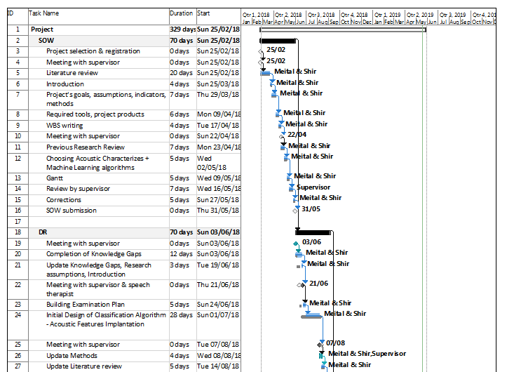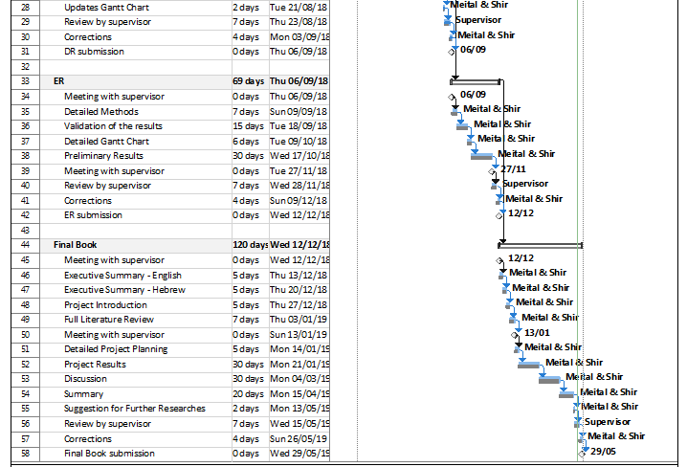

## **13.2 Changes Assemblage**

Table 9 summarizes the changes decisions through the final project.

|  |  |  |  |  |  |
| --- | --- | --- | --- | --- | --- |
| **Project Volume** | **The Initiator** | **Date** | **Relevant Part** | **The Change** |  |
| Increase Volume | Supervisor | 13/09/2018 | Methods | Find Peaks Algorithm | 1 |
| Increase Volume | Supervisor & Students | 11/10/2018 | Methods | VAD Algorithm | 2 |
| Increase Volume | Supervisor & Students  Table 9 – Change Assemblage Summarize | 11/10/2018 | Methods | Original Parameters | 3 |

1. Find Peaks Algorithm was implemented. MATLAB "FindPeaks" built algorithm was not sufficient and accurate enough to find jitter and shimmer of Parkinson speakers.
2. VAD algorithm implementation was changed. Thresholds of autocorrelation coefficient R1, LPC residual, STFT maximal amplitude and F0 were added to help distinguish between voiced and unvoiced segments
3. Original parameters extracted from the signal was added aiming to evaluate the periodic nature of the signal and to quantify the level of disarrayed frames.

# **14. References**

## **14.1 Article**

1. Savitt, J. M., Dawson, V. L., & Dawson, T. M., "Diagnosis and treatment of Parkinson disease: molecules to medicine", The Journal of Clinical Investigation, , pp.1744-1754, 2006
2. Rusz, J., Cmejla, R., Ruzickova, H., & Ruzicka, E., "Quantitative Acoustic Measurements for Characterization of Speech and Voice Disorders In Early Untreated Parkinson’s Disease",[The Journal of the Acoustical Society of America](https://www.medvik.cz/bmc/view.do?gid=2565), pp. 350-367, 2011.
3. National institute of Neurological Disorders and stroke (NINDS), "Parkinson's Disease: Challenges, Progress, and Promise". Accessed May 25, 2018.  
   https://www.ninds.nih.gov/Disorders/All-Disorders/NINDS-Parkinsons-Disease-Information-Page/Parkinsons-Disease-Challenges#about.
4. Karimi Rouzbahani, H., & Daliri, M. R., "Diagnosis of Parkinson’s Disease in Human Using Voice Signals", Basic and Clinicalneuroscience*,* pp. 12-20,2011*.*
5. Rao, S. S., Hofmann, L. A., & Shakil, A., "Parkinson’s Disease: Diagnosis and Treatment", American Family Physician, pp. 2046-2054, 2006.

1. [Quatieri](https://www.amazon.com/s/ref=dp_byline_sr_ebooks_1?ie=UTF8&text=Thomas+F.+Quatieri&search-alias=digital-text&field-author=Thomas+F.+Quatieri&sort=relevancerank)  T.F, Production and Classification of Speech Sounds (Chapter 3) in: Discrete Time Speech Signal Processing: Principles and Practice, Prentice Hall, United States, 2006, pp. 55-110.
2. Joseph R. Duffy, Hypokinetic Dysarthria (Chapter 7) in: Motor Speech Disorders: Substrates, Differential Diagnosis and Management (First Ed.), Mosby, United States, 1995, pp. 187-215.
3. Karimi Rouzbahani, H., & Daliri, M. R, "Diagnosis of Parkinson’s Disease in Human Using Voice Signals", Basic and Clinical Neuroscience, pp.12-20, 2011.
4. Tiwari, A. K., "Machine Learning Based Approaches for Prediction of Parkinson's Disease", Mach Learn Appl, pp. 33-39, 2016.
5. Teixeira, J. P., & Fernandes, P. O., "Jitter, Shimmer and HNR Classification Within Gender, Tones and Vowels in Healthy Voices", Procedia Technology, pp.1228-1237, 2014.
6. Shimamura, T., & Kobayashi, H., "Weighted Autocorrelation for Pitch Extraction of Noisy Speech", IEEE Transactions on Speech and Audio Processing, pp. 727-730, 2001.
7. Bachu, R. G., Kopparthi, S., Adapa, B., & Barkana, B. D. "Separation of voiced and unvoiced using zero crossing rate and energy of the speech signal", American Society for Engineering Education (ASEE) Zone Conference Proceedings (pp. 1-7), 2008
8. ‏ RAIKWAL, J. S.; SAXENA, Kanak. "Performance evaluation of SVM and k-nearest neighbor algorithm over medical data set". International Journal of Computer Applications, 2012.‏
9. J. Sujatha, S.P. Rajagopalan, "Performance Evaluation of Machine Learning Algorithms in the Classification of Parkinson Disease Using Voice Attributes". International Journal of Applied Engineering Research, pp.10669-10675, 2017.

## **14.2 Figure**

1. MedIndia, "Parkinson’s Disease - Causes, Symptoms, Diagnosis, Treatment" https://www.medindia.net/patients/patientinfo/Parkinsonsdisease.htm
2. Shutterstock, "Parkinson's Disease Symptoms and Signs" https://www.shutterstock.com/image-vector/parkinsons-disease-symptoms-signs-illustration-about-754057981

1. [Quatieri](https://www.amazon.com/s/ref=dp_byline_sr_ebooks_1?ie=UTF8&text=Thomas+F.+Quatieri&search-alias=digital-text&field-author=Thomas+F.+Quatieri&sort=relevancerank)  T.F, Production and Classification of Speech Sounds (Chapter 3) in: Discrete Time Speech Signal Processing: Principles and Practice, Prentice Hall, United States, 2006, pp. 55-110.

1. [Quatieri](https://www.amazon.com/s/ref=dp_byline_sr_ebooks_1?ie=UTF8&text=Thomas+F.+Quatieri&search-alias=digital-text&field-author=Thomas+F.+Quatieri&sort=relevancerank)  T.F, Production and Classification of Speech Sounds (Chapter 3) in: Discrete Time Speech Signal Processing: Principles and Practice, Prentice Hall, United States, 2006, pp. 55-110.
2. Serge Pinto, Canan Ozsancak, "Treatments for dysarthria in Parkinson’s disease" <http://www.lpl-aix.fr/~fulltext/3022.pdf>
3. Staesthetic, "Statistics, Mathematics, Optimization and Aesthetics"

https://staesthetic.wordpress.com/2014/04/14/gini-roc-auc-and-accuracy/

1. J. Sujatha, S.P. Rajagopalan, "Performance Evaluation of Machine Learning Algorithms in the Classification of Parkinson Disease Using Voice Attributes". International Journal of Applied Engineering Research, pp 10669-10675, 2017.

# **15 Appendix**

## **15.1 Poster**

## **15.2 Relevant Article**

The following article describes method of diagnosing Parkinson's Disease through speech feature extraction with KNN and SVM machine learning algorithms, located under "ARTICLE" folder at the attached project's disk:

Karimi Rouzbahani, H., & Daliri, M. R, "Diagnosis of Parkinson’s Disease in Human Using Voice Signals", Basic and Clinical Neuroscience, pp.12-20, 2011.

## **15.3 Advisor's Approval**

